**Intro to Chromebooks**

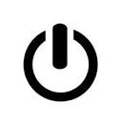

**Power button**

**Login screen**

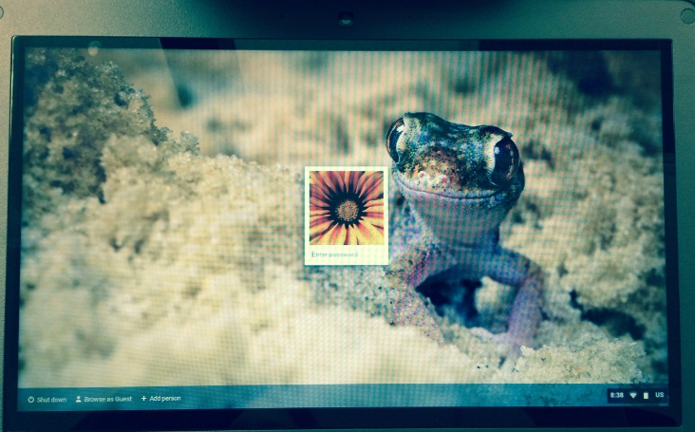

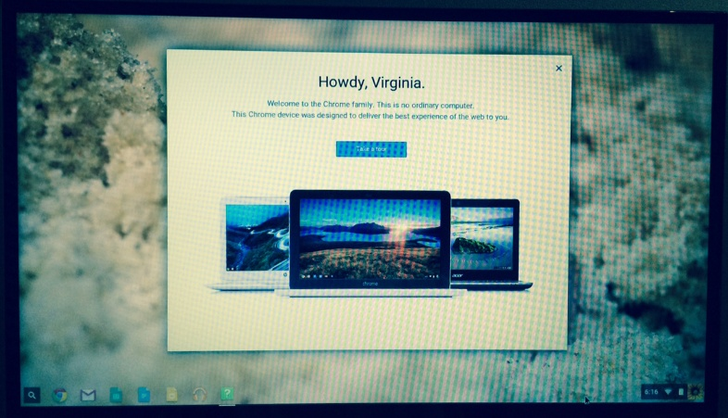

**Tour button**

**Search** **Status tray**

**Apps**



**Network** **Battery**