SOUTHERN OREGON ADMINISTRATOR MENTOR COLLABORATIVE LOG
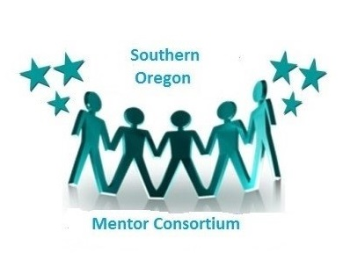
Mentee: Mentor: Date:
What’s working? | Current focus, challenges, concerns?
Mentee’s next steps? | Mentor’s next steps?
 | Next meeting agenda?
 | Next meeting date and time?
Oregon Administrative Standards:
- Visionary Leadership – Develop a vision that promotes success of all students; Articulate a vision; Implement a vision; Steward a vision
- Instructional Improvement – Positive school culture; Effective instructional program; Best practice to student learning; Design comprehensive professional growth plans
- Effective Management – Manage the organization; Manage operations; Manage resources
- Inclusive Practice – Collaborate with families and other community members; Respond to community interests and needs; mobilize community resources
- Ethical Leadership – Act with integrity; Act fairly, Act ethically
- Socio-Political Context – Understand the larger context; Respond to the larger context; Influence the larger context

