Arithmetic in Support of Algebra (and Geometry)

How do we know students know what we think we’ve taught ‘em? Metaphors, iconic graphics, and multiple representations may be indicators. If students (or people!) know only one way of doing or thinking about something and/or can’t really explain why they do it a certain way, we suspect that they don’t really know what they’re doing. But when students can say something is like something else—say, solving linear equations in one unknown is like working with a balance scale (or like finding where their equivalent lines intersect) or that multiplication and division relationships are like a rectangle where the area is the product of the sides (factors). Or that counting forwards and backwards is like moving left or right on a number line. Or that a system of integers is just another number line going the other way from zero. Or that rational numbers (fractions) are finer and finer divisions of the spaces between the spaces between the units on a number line. Or that irrational numbers are numbers you can’t ever quite pin down to a division, no matter how fine you get. Or that multiplication is like repeated addition is like hops on a number line is like patterns on a 10x10 grid is like stacks of one-by-whatever rows in a rectangular array. And so on. Here’s a loose collection of media and tools for multiple representations that may give you some ideas to explore or with plenty of graphics—if you grab this in .doc format—to snag and use.

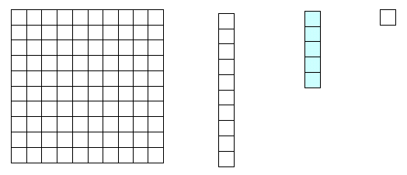
counting
units (what are you counting)
number names
zero—what a concept!
base ten system (composition and decomposition)
stacking
dimension 0 = 1 cm x 1 cm x 1 cm unit cube
dimension 1 = 10 cm x 1 cm x 1 cm long length
dimension 2 = 10 cm x 10 cm x 1 cm flat area (length x width)
dimension 3 = 10 cm x 10 cm x 10 cm 1000-cube volume (length x width x height)
number line: natural numbers (include zero)
a ray originating at zero
1
2
3
4
5
6
7
8
9
10
11
12
13
0

number line: integers (left and right)
a line stretching infinitely in both + and – directions with zero at its midpoint
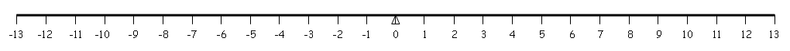
construct a number line with compass and straightedge

adding and subtracting

Because a main goal of this course is teaching kids to compose, decompose, and recompose numbers and because all these kids have already been exposed to and learned something about basic operations in grades K-3 and because both are so closely related, addition and subtraction should be taught together.
number line combining
4 facts: 8+2 = 10, 2+8=10, 10-2=8, 10-8=2
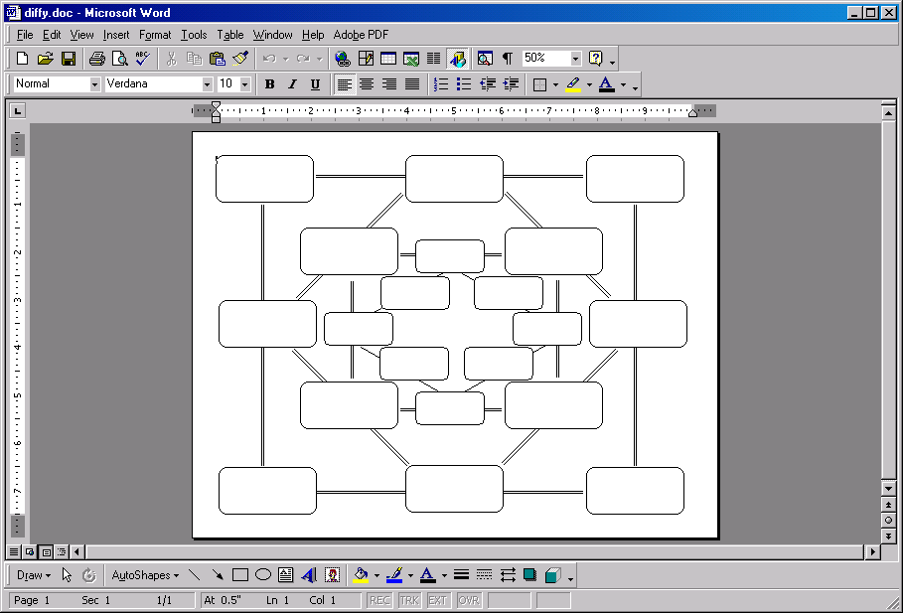
number line comparing
blank diffy
what’s the difference between 10 and 2?
how much do you have to add to 2 to get 10?
and on the second pass: how much do you have to add to 8 to get 2?
diffies: roll dice to build problems (see more on dice, below)
use 20-sided dice with first timers,
graduate to larger numbers: separate dice for ones, tens, even hundreds!
for online diffies, see the National Library of Virtual Manipulatives:
http://nlvm.usu.edu/en/nav/frames_asid_326_g_2_t_1.html
graph number combinations to 10: x + y = 10
skip-counting (multiplication)
race games: race up and back to 20, 100, 1000, 10,000
see an overview at http://www.soesd.k12.or.us/files/race_games.pdf
fluency/automaticity: time tests with Holey Cards and used paper
n – n = 0 additive inverse
n + 0 = n identity element for addition

regrouping in base 10 (composition and decomposition)

trading in accumulations (stacks) of ten for the next higher unit
trading in a block for ten of the next lower type
counting strips
race games up and back to 20, to 100, to 1000, to 10,000
diffies
grids
addition facts, multiplication facts and skip counting
place value, numbers to 100 (then numbers to 120)

equal chunks of number lines can be stacked into grids—twos, fives, and tens are common and intuitive

1 | 2 | 3 | 4 | 5 | 6 | 7 | 8 | 9 | 10 |  | 1 | 2 | 3 | 4 | 5 | 6 | 7 | 8 | 9 | 10
11 | 12 | 13 | 14 | 15 | 16 | 17 | 18 | 19 | 20 |  | 11 | 12 | 13 | 14 | 15 | 16 | 17 | 18 | 19 | 20
 |  |  |  |  |  |  |  |  |  |  | 21 | 22 | 23 | 24 | 25 | 26 | 27 | 28 | 29 | 30
1 | 2 | 3 | 4 | 5 | 6 | 7 | 8 | 9 | 10 |  | 31 | 32 | 33 | 34 | 35 | 36 | 37 | 38 | 39 | 40
11 | 12 | 13 | 14 | 15 | 16 | 17 | 18 | 19 | 20 |  | 41 | 42 | 43 | 44 | 45 | 46 | 47 | 48 | 49 | 50
21 | 22 | 23 | 24 | 25 | 26 | 27 | 28 | 29 | 30 |  | 51 | 52 | 53 | 54 | 55 | 56 | 57 | 58 | 59 | 60
 |  |  |  |  |  |  |  |  |  |  | 61 | 62 | 63 | 64 | 65 | 66 | 67 | 68 | 69 | 70
1 | 2 | 3 | 4 | 5 | 6 | 7 | 8 | 9 | 10 |  | 71 | 72 | 73 | 74 | 75 | 76 | 77 | 78 | 79 | 80
11 | 12 | 13 | 14 | 15 | 16 | 17 | 18 | 19 | 20 |  | 81 | 82 | 83 | 84 | 85 | 86 | 87 | 88 | 89 | 90
21 | 22 | 23 | 24 | 25 | 26 | 27 | 28 | 29 | 30 |  | 91 | 92 | 93 | 94 | 95 | 96 | 97 | 98 | 99 | 100
31 | 32 | 33 | 34 | 35 | 36 | 37 | 38 | 39 | 40
 |  |  |  |  |  |  |  |  |  |  | 1 | 2 | 3 | 4 | 5 | 6 | 7 | 8 | 9 | 10
1 | 2 | 3 | 4 | 5 | 6 | 7 | 8 | 9 | 10 |  | 11 | 12 | 13 | 14 | 15 | 16 | 17 | 18 | 19 | 20
11 | 12 | 13 | 14 | 15 | 16 | 17 | 18 | 19 | 20 |  | 21 | 22 | 23 | 24 | 25 | 26 | 27 | 28 | 29 | 30
21 | 22 | 23 | 24 | 25 | 26 | 27 | 28 | 29 | 30 |  | 31 | 32 | 33 | 34 | 35 | 36 | 37 | 38 | 39 | 40
31 | 32 | 33 | 34 | 35 | 36 | 37 | 38 | 39 | 40 |  | 41 | 42 | 43 | 44 | 45 | 46 | 47 | 48 | 49 | 50
41 | 42 | 43 | 44 | 45 | 46 | 47 | 48 | 49 | 50 |  | 51 | 52 | 53 | 54 | 55 | 56 | 57 | 58 | 59 | 60

make your own grids in Excel or Word or download them from www.soesd.k12.or.us/math

arrays (The area model for multiplication and division)

If you stack the skip counting chunks from the grids above, or the hops from a number line, you get a rectangular array These rectangular arrays are the basis of the area model of multiplication and division. Here are some arrays that show common math facts from the times tables:

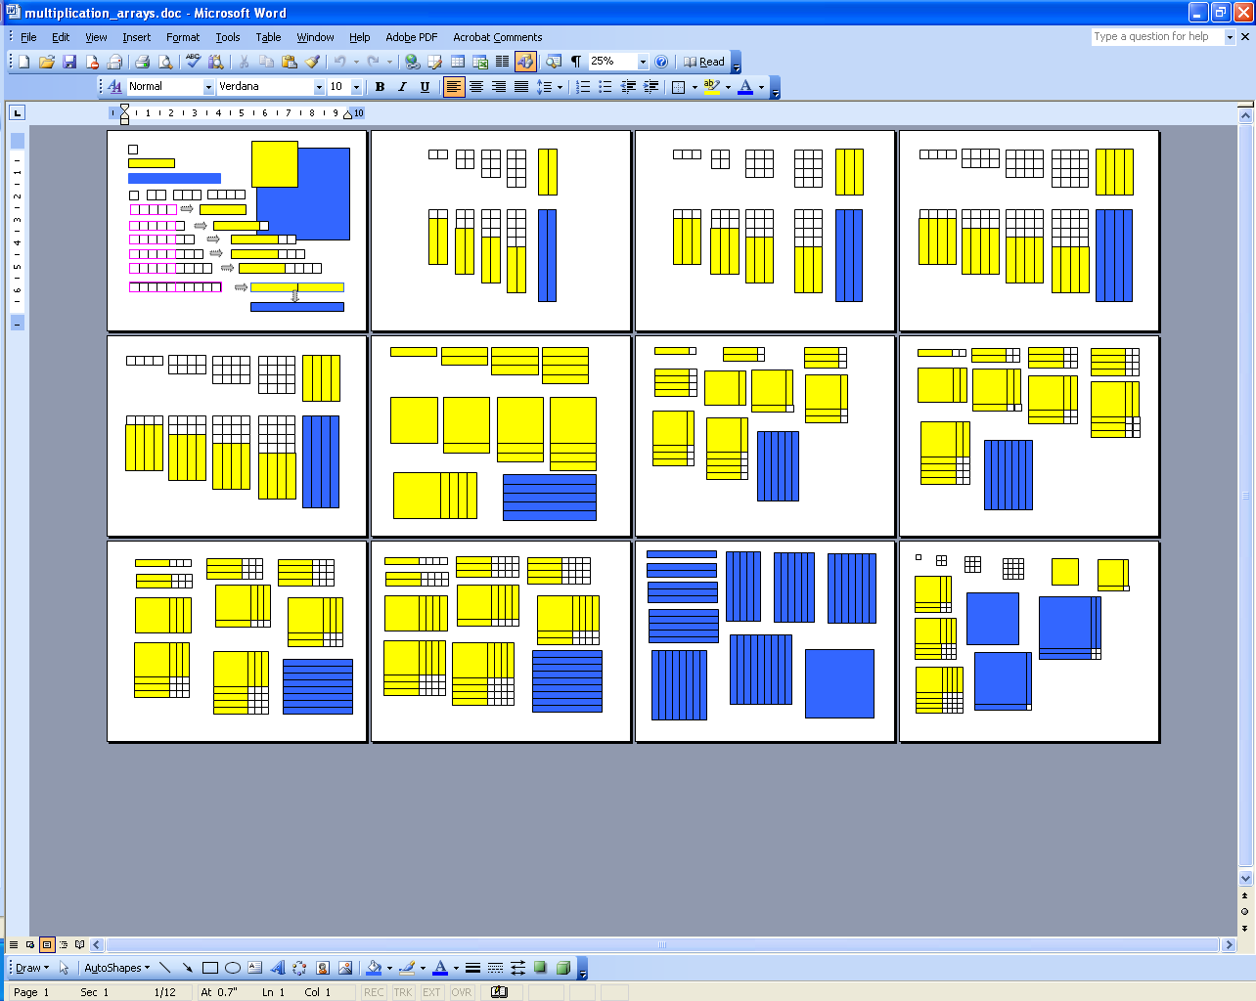
x 2
x 3
x 4
x 5
x 6
x 10
A rectangular array captures any multiplication or division relationship
factor
factor
product
quotient
divisor
dividend

or

Both of these are restatements of the same thing, since m/n = k means m = n • k

(Thanks to Professor Hung-Hsi Wu of UC Berkeley who led us through the derivation and exploration of these during a summer institute class of his we were lucky enough to be able to attend. See also his “Chapter 2: Fractions (Draft) at http://math.berkeley.edu/%7Ewu/EMI2a.pdf )

Here are illustrations of a couple of fractions 3/4 and 24/6:
4
3
3

4

4

6
24

multiplying and dividing
Multiplication and division should be taught together for the same reasons as with addition and subtraction, above.

arrays--4 facts: 8x2=16, 2x8=16, 16÷2=8, 16÷8=2
skip counting forwards & backwards (repeated addition and subtraction)
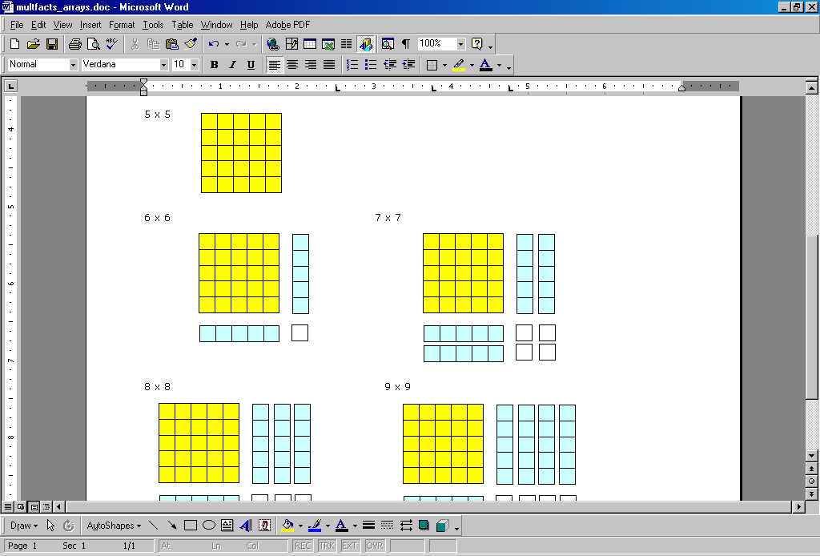
BUT YOU HAVE TO GET TO THE AREA MODEL BECAUSE REPEATED ADDITION
AND SUBTRACTION DON’T WORK WITH POLYNOMIALS
(unless you picture adding x repeatedly x times)
7 x 7 = 49

7 x 7 = 25 + 10 + 10 + 4 = 49
skip counting groups and bundles
stacking skip-counting steps into arrays (include 5x5 flats)
tables
fluency/automaticity: Holey Cards
gzinta (“goes-into”) number x 1/n = 1 or n/n = 1 multiplicative inverse
n x 1 = n identity element for multiplication
exponents n⁰, n¹, n², n³, n⁻¹, n⁻², n⁻³

This area model for multiplication should be the goal for pre-secondary education.
(See Stanley Ocken’s “Algorithms, Algebra, and Access” http://www.nychold.com/ocken-aaa01.pdf for strong reasons why the area model is critical for an understanding of multiplication and division.)
5 + 2
25
4
10
10
5
2
+
(5 + 2) ● (5 + 2) = 49

7 x 7 = 25 + 10 + 10 + 4 = 49
This leads right into the standard algorithm for multiple-digit multiplication:

And the coming-together of the standard algorithm for multiplication, the area model for multiplication and division, and standard base 10 place value, leads right into multiplying polynomials—whether it be with base ten blocks, algebra tiles, foiling, or whatever:
x + 2
x²
4
2x
2x
x
2
+
(x + 2) ● (x + 2) = x² + 2x + 2x + 4

(x + 2) ² = x² + 4x + 4
x + 2
x + 2
x
2x + 4
x² + 2x
x² + 4x + 4

Consider 12 x 23:

10 + 2
x
30 + 6
200 + 40
20 + 3
200 + 70 + 6

23
12
x
6
30
40
200
276

standard algorithm
showing partial products
seen as a polynomial
dimensioned
with base 10 blocks
filled-in

10 + 2
200
6
40
30
20
3
+
(10 + 2) ● (20 + 3) = 276

12 x 23 = 200 + 40 + 30 + 6 = 276
seen in the not-to-scale
polynomial grid

Now consider how similar is ( x + 2 ) ● (2x + 3) :
x

x

x

(This is why the area model is so essential.)

x + 2
x²

2x + 3
3x + 6

2x² + 4x
x²

2x² + 7x + 6

x + 2
2x²
6
4x
3x
2x
3
+
(x + 2) ● (2x + 3) = 2x² + 4x + 3x + 6 = 2x² + 7x + 6

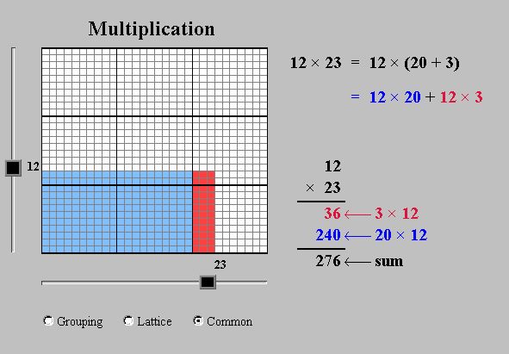
For an online, interactive look at the area model, go to
the National Library of Virtual Manipulatives http://nlvm.usu.edu/en/nav/frames_asid_192_g_2_t_1.html

fractions
3/4
1/3
5/6
2/5
diffy with fractions
number line: rational numbers
fractions of a whole
fractions of a group
number line: distance in steps taken/distance in steps to the goal
arrays: percent or fraction of coverage
common
improper
adding and subtracting: diffies
common denominators
reducing fractions
mixed numbers
decimals
percents
picturing
equivalent fractions
factoring: make a table and graph it; use Excel if you like (see the example in graphing x-y coordinates, below)
chance (what are the chances of rolling a 1? a 6, a 9?)
what is the chance that I will win? that somebody will win?
what is the chance that I will roll a 39? (a 3 on one die, a 9 on the other)
what is the chance that Valentine’s Day will be on a Sunday?
n/n = 1/1 = 1 = 100/100 = 100%

to give students an idea of what’s happening in multiplication and division of fractions, a table works very well:
It’s pretty easy to see that when you multiply 3 by smaller and smaller numbers, you get smaller and smaller answers. Particularly, when you multiply it by less than 1, you get less than 3.

And it’s pretty easy to see that when you divide something by smaller and smaller numbers, you get bigger and bigger results.
3x = y
 | x | y
3 | 4 | 12.00
3 | 2 | 6.00
3 | 1 | 3.00
3 | 0.50 | 1.50
3 | 0.25 | 0.75
3/x = y
 | x | y
3 | 4 | 0.75
3 | 2 | 1.50
3 | 1 | 3.00
3 | 0.50 | 6.00
3 | 0.25 | 12.00
as x gets smaller, y gets smaller
as x gets smaller, y gets bigger

And, of course, since it’s multiplication and division,
3/5 x 1/2 can be pictured as a rectangular array:

3/5
1/2
3/10

dimensions (0, 1, 2, 3)
units (counting, distance, area, volume)
appropriate units
unit equations
distance around (perimeter) vs. area covered string (BL) and 3″ x 5″ index cards (BL)
arrays (covering)
area of rectangles and squares
Area always has something to do with base x height (length x width) and any triangle will be half of a parallelogram.

So really, there’s just b*h (and b*h/2 for triangles) and πr² for circles
area of parallelograms and rhombi
area of trapezoids
area of triangles
area of a unit circle—use 3 x 5 card method (BL)
volume (filling)
mapping, scaling, and modeling (distance and area)
the classroom, the school
use Google maps to see this big-time and online

reading and writing sentences (linear equations)
2 + 2 = 4
2 + x = 4
x + y = 4

tables
x and y values
multiplying by fractions (x 4, x 3, x 2, x 1, x ½, x 1/3, x ¼)
possible outcomes (rolls of a dice)

graphing x-y coordinates
Basic operations (addition, subtraction, multiplication, division) should be pictured on coordinate axes. This is one way into higher math. Probably on the first pass, teachers will want to omit the negative numbers and stay in the first quadrant. On the second pass, the negative numbers should certainly be included as well as fractional values for x and y. Excel does fine tables (below) and okay graphs, but for good graphs, go to http://www.shodor.org/interactivate/activities/flyall/
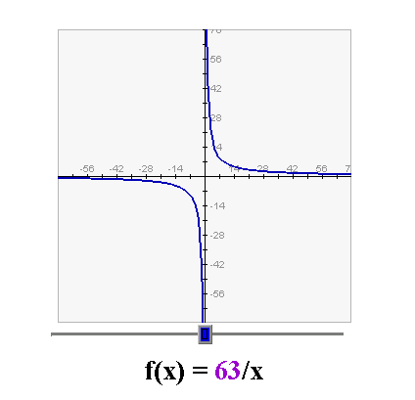
x | y
xy = 63
63 | 1
21 | 3
7 | 9
3 | 21
1 | 63
-63 | -1
-21 | -3
-7 | -9
-3 | -21
-1 | -63

It’s easier on the eye, I think, if you tell Excel to center the values and if you merge the cells in the second row and put the equation in there.

For the graph, I generally like to use Scatter.

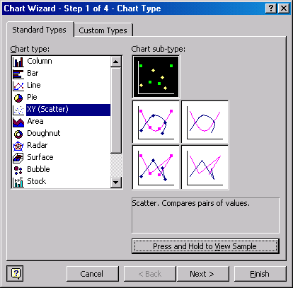

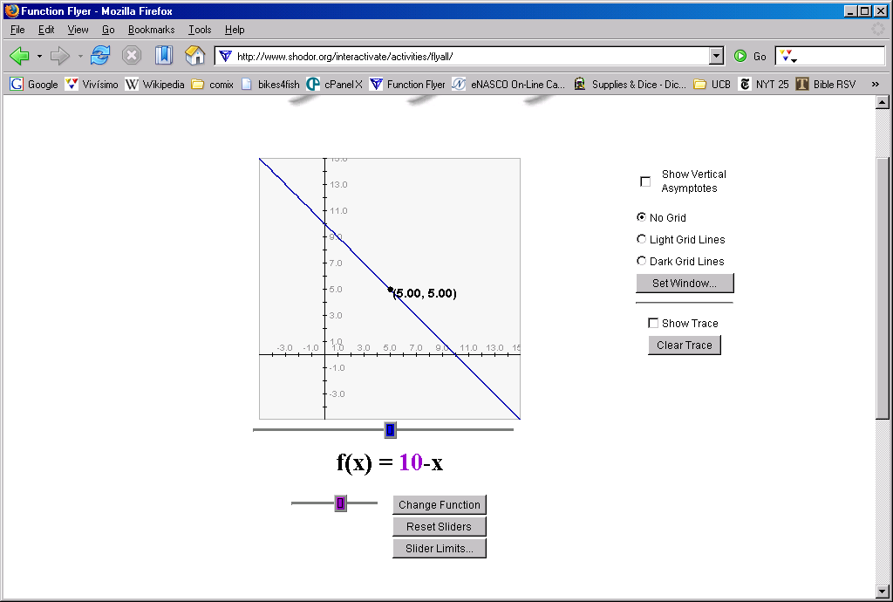

x | y
x + y = 10
0 | 10
1 | 9
2 | 8
3 | 7
4 | 6
5 | 5
6 | 4
7 | 3
8 | 2
9 | 1
10 | 0

constructions
Constructions with compass and straightedge will give everybody a visceral, kinesthetic connection with geometry. It probably would be a good idea for students (and teachers) to write down each step on the side.
line segment (connecting two points)
circle
copy line segment
perpendicular bisector of a line segment
angle
copy angle
bisect angle
triangle from three given lengths, as long as the two shortest ones put end-to-end are longer than the longest
square
line parallel to a given line
square with circumscribed circle
square with inscribed circle
triangle with circumscribed circle
triangle with inscribed circle

stylistic protocols: show your work (download the PowerPoint from www.soesd.k12.or.us/Page.asp?NavID=776 )
Work that’s not done along these lines simply doesn’t meet class standards and is therefore incomplete and can’t be accepted.
draw a diagram,
skip lines or leave a space between lines,
box your answer,
check your work

boardwork protocols
All of us need to know how to explain our stuff. Some people are shy; some love the limelight. Whatever. All students should have to do work at the board, but we need to set them up for success: they should do a problem they have worked on and polished with a peer coach, making sure that they follow the stylistic protocols above.

problem solving heuristics and mnemonics
show what you know: draw a diagram
list what you know: define variables
make a table of values
use movement to remember
open your hands to 30°, 120°, 90°
turn through 180°
put your elbows together and form a 90° angle with your forearms

conventions
parentheses for grouping and multiplication
* means multiplication
3 squared looks like this and equals 9
/ means division, sometimes separates numerator and denominator
order of operations
superscript: 3² means three squared
3*3, 3^2 also means 3² and thus 3*3
x = “x” or one times x; 3x = “three x” or three times x.

number lines
number line: natural numbers (include zero)
number line: integers (left and right)
number line: rational numbers (fractions)
number line: real numbers (roots, plus transcendental numbers like pi and e)
coordinate axes are just number lines rotated 90° around zero

dice
Rolling dice is a good way for students to create—and own!—their own problems. Using dice also keeps problems from being too predictable and boring and keeps problems robust enough to allow—and force!—students to generalize. A bad side effect of many worksheets is that students get trained in an algorithm rather than gaining a deeper understanding of the problem space. Dice are an important part of race games and diffies. Here’s an example that uses three kinds of dice, five in all, that creates a sum, remainder, product, or quotient in the rational numbers:
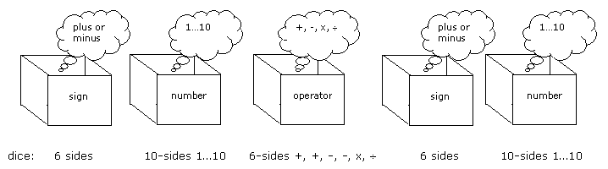

- dice with + or minus on each of six faces
- dice with add, subtract, multiply, or divide on each of six faces
- dice with 1…10 or 0…9 on each of ten faces

Here are a few more suggestions for dice:

- dice with 1/2, 1/3, 2/3, 1/6, 5/6, and 0 on each of 6 faces
- dice with 1/2, 1/3, 2/3, 1/6, 5/6, 1/12, 5/12, 7/12, 11/12, 1/4, 3/4, and 0 on a 12-sided die—or just use the 6-sided die above with halves, thirds, sixths, and zero along with another 6-sided die with the remaining fourths and twelfths.

You could use these to race for a pattern block flower or even for a couple of egg cartons.
For more about race games, see “adding and subtracting”, above and an overview of race games at
http://www.soesd.k12.or.us/files/race_games.pdf
And you can download virtual 10-sided dice from http://www.soesd.k12.or.us/Page.asp?NavID=741

data management (statistics, probability, chance)
Students—and classrooms!—should keep track of how they’re doing, set targets, evaluate their progress, and troubleshoot difficulties. They can use dice to build their own problems (see above) and begin to get an appreciation for how chance works.

resources

See SOESD’s math pages at www.soesd.k12.or.us/math and look at the navigation bar for Algebra Through Visual Patterns and Annenberg resources, plus our math resources at www.soesd.k12.or.us/math/math_resources

These are the best places I’ve found on the web for javascript problemspaces:

National Library of Virtual Manipulatives: http://matti.usu.edu/nlvm/nav/vlibrary.html
Project Interactivate: http://www.shodor.org/interactivate/
Links to my favorites, along with short explanatory blurbs are at http://www.soesd.k12.or.us/files/manipulinks.pdf
Templates, handouts, rants, and overviews are at SOESD’s Math Resources page www.soesd.k12.or.us/math
PowerPoints and MS Office graphics techniques are at SOESD’s training page, www.soesd.k12.or.us/support/training

There are some essays online, that will inform and provoke your thinking. Here are some of my favorites:

Howe, Roger. “Taking Place Value Seriously: Arithmetic, Estimation and Algebra”. http://www.maa.org/pmet/resources/PlaceValue_RV1.pdf

Ocken, Stanley. “Algorithms, Algebra, and Access”. http://www.nychold.com/ocken-aaa01.pdf

Schoenfeld, Alan. “Mathematics Teaching and Learning”. http://gse.berkeley.edu/faculty/AHSchoenfeld/Schoenfeld_MathTeachingAndLearning.pdf (Schoenfeld’s homepage http://gse.berkeley.edu/faculty/AHSchoenfeld/AHSchoenfeld.html has other interesting essays that can be downloaded in pdf format.)

Wu, Hung-Hsi. “How to Prepare Students for Algebra”, American Educator, Summer 2001, Vol. 25, No. 2, pp. 10-17. http://www.aft.org/pubs-reports/american_educator/summer2001/index.html

Wu, Hung-Hsi. “Introduction to School Algebra [DRAFT]”. http://math.berkeley.edu/~wu/Algebrasummary.pdf (Wu’s homepage http://math.berkeley.edu/~wu/ has other interesting essays that can be downloaded in pdf format.)

Wu, Hung-Hsi. “Key Mathematical Ideas in Grades 5-8”. http://math.berkeley.edu/~wu/NCTM2005a.pdf

Wu, Hung-Hsi. “Chapter 2: Fractions (Draft)”. http://math.berkeley.edu/%7Ewu/EMI2a.pdf

Larry Francis, Southern Oregon ESD Computer Information Services
www.soesd.k12.or.us/support/training and www.soesd.k12.or.us/math
larry_francis@soesd.k12.or.us or 541.858.6748

revised 7/30/2026

