f(x) = 2x
f(x) = 2^{x}
f(x) = x²
f(x) = log₂x

x is the input, whatever it is
f(x) is the output, a function of the input
= defines the relationship that turns the input into the output

Each of these has the same elements:

2
x
f(x)

But they don’t mean the same thing:

output = 2 times the input
f(x) = 2x
output = the input squared
output = 2 raised to the power of the input
output = the power of 2 that gives you the input

Here’s what the graphs look like (from www.shodor.org/interactivate/activities/FunctionFlyer)
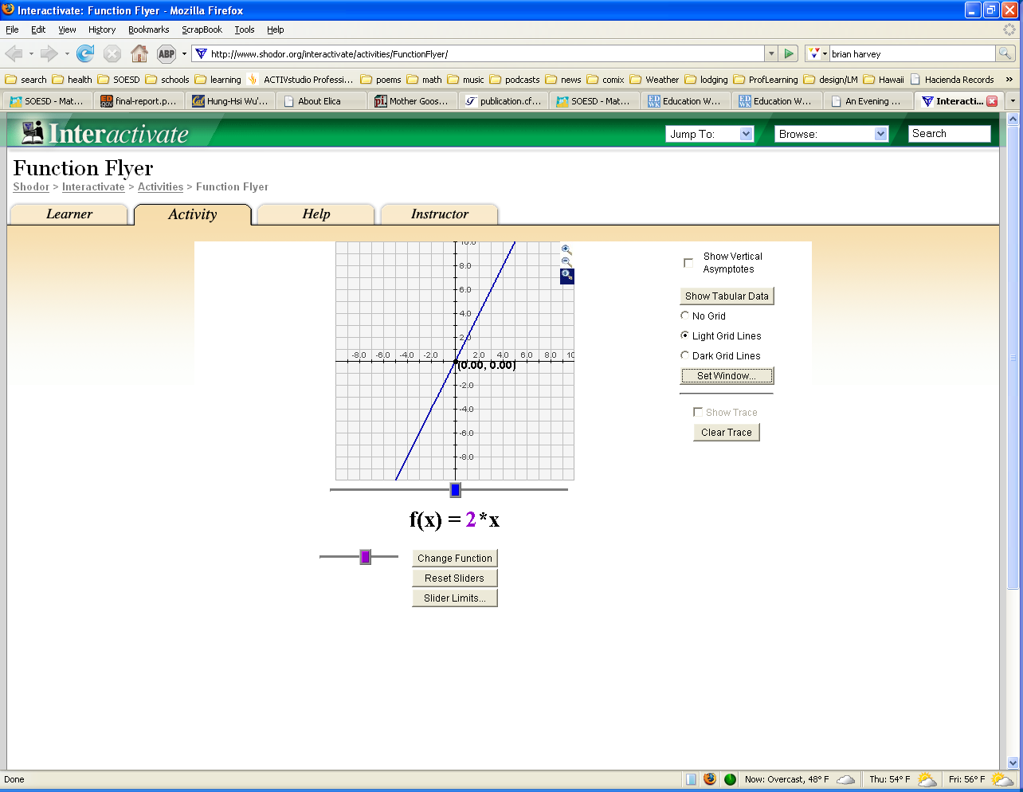
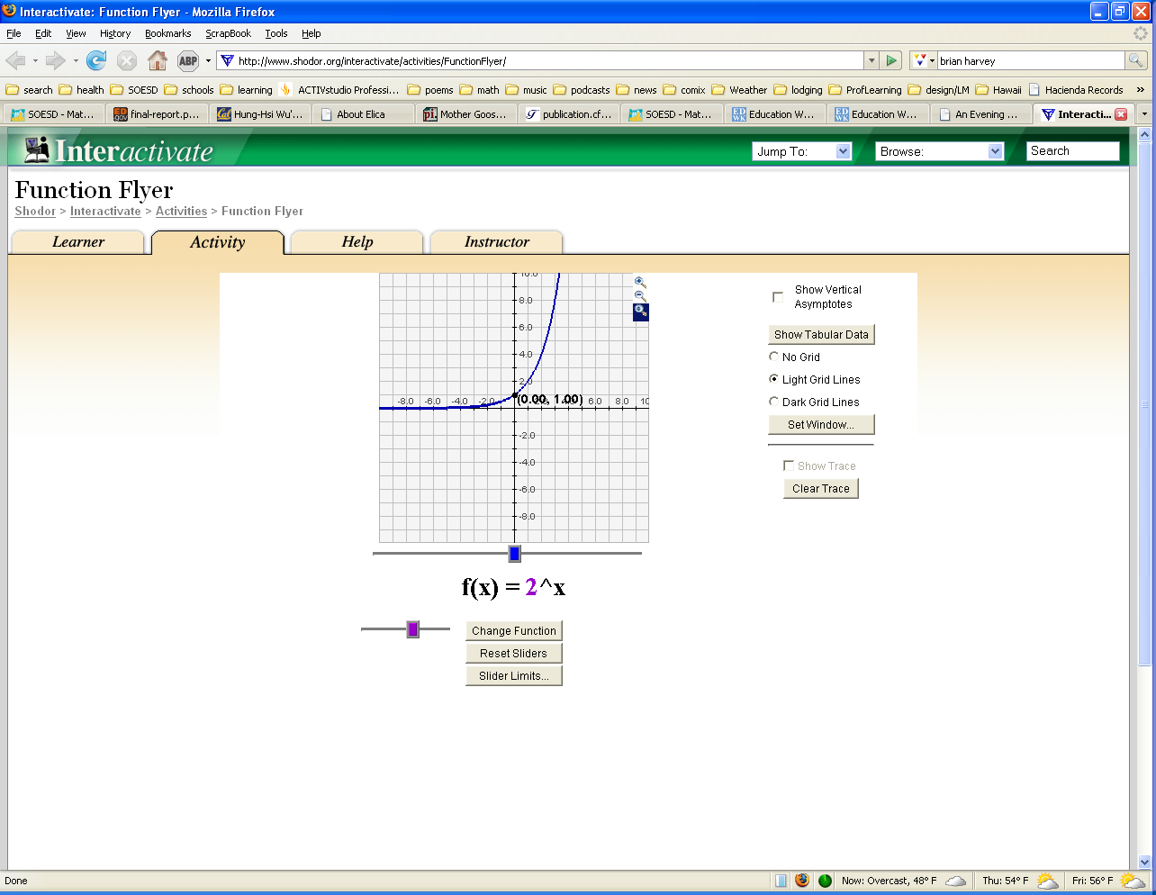
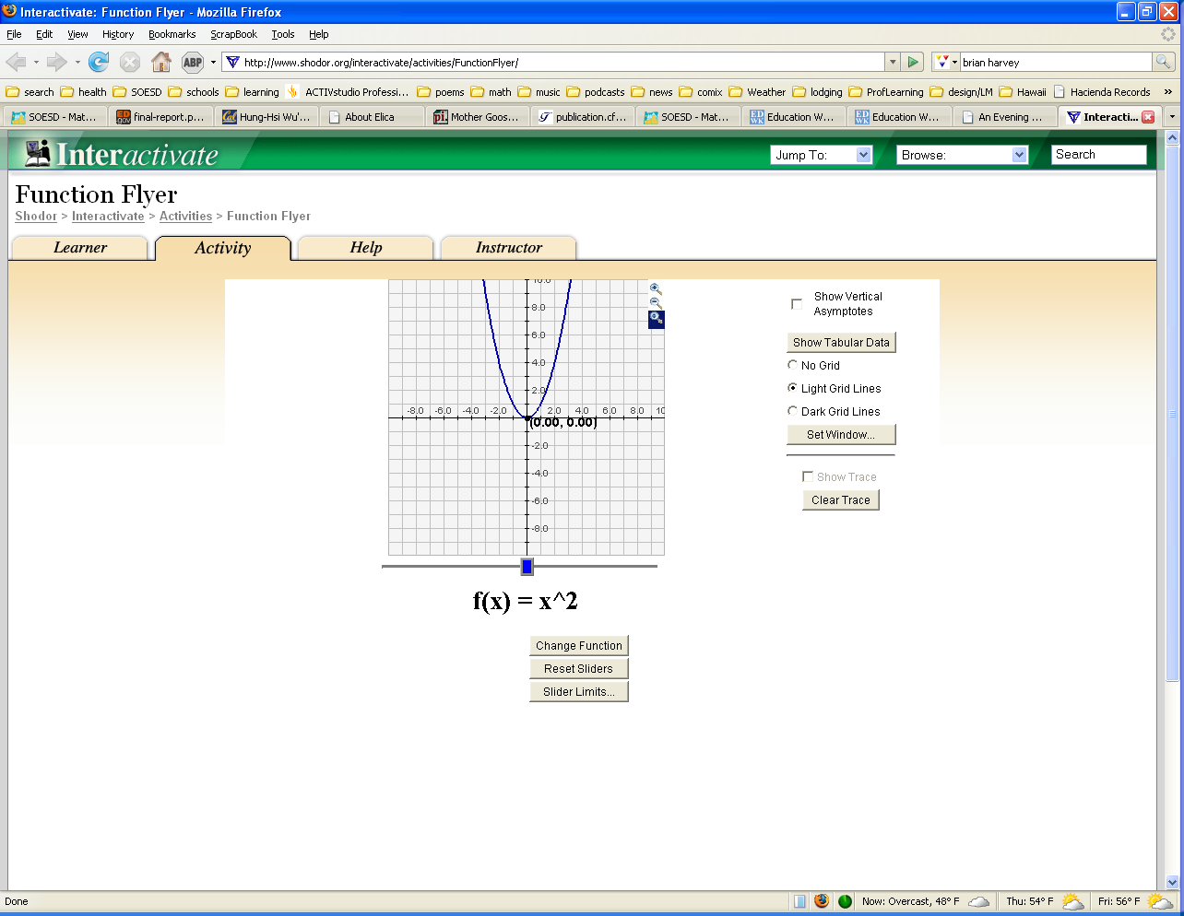
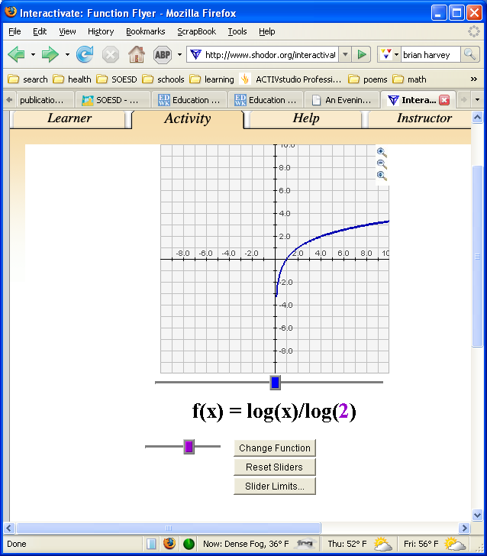
f(x) = 2x
f(x) = 2^{x}
f(x) = x²
f(x) = log₂x

Here’s what the tables look like (see www.soesd.k12.or.us/files/input_output_excel.xls for Excel doc)

x 2x x² 2^{x} log₂x

1 |  | 2 |  | 1 |  | 2 |  | 0
2 |  | 4 |  | 4 |  | 4 |  | 1
3 |  | 6 |  | 9 |  | 8 |  | 1.584962501
4 |  | 8 |  | 16 |  | 16 |  | 2
5 |  | 10 |  | 25 |  | 32 |  | 2.321928095
6 |  | 12 |  | 36 |  | 64 |  | 2.584962501
7 |  | 14 |  | 49 |  | 128 |  | 2.807354922
8 |  | 16 |  | 64 |  | 256 |  | 3
9 |  | 18 |  | 81 |  | 512 |  | 3.169925001
10 |  | 20 |  | 100 |  | 1024 |  | 3.321928095
11 |  | 22 |  | 121 |  | 2048 |  | 3.459431619
12 |  | 24 |  | 144 |  | 4096 |  | 3.584962501
13 |  | 26 |  | 169 |  | 8192 |  | 3.700439718
14 |  | 28 |  | 196 |  | 16384 |  | 3.807354922
15 |  | 30 |  | 225 |  | 32768 |  | 3.906890596
16 |  | 32 |  | 256 |  | 65536 |  | 4

