

Southern Oregon University, Ashland, Oregon


This was a wonderful experience! Thought-provoking topics and ideas for reaching ALL kids ...such an honest dialogue is refreshing...I think we're onto something with PBS! . -2008 Participant

Thursday, October 15 Middle School & High School Keynote Speaker: Matt Coleman, Ph.D. Director of Secondary Education Springfield School District

Wednesday, October 14 Early Childhood & Elementary Keynote Speaker: Annemieke Golly, Ph.D. Institute on Violence and Destructive Behavior University of Oregon


For more information, contact Kathy Helgeson Southern Oregon ESD 541-601-2453 kathy_helgeson@soesd.k12.or.us
“We’re all in this together!”
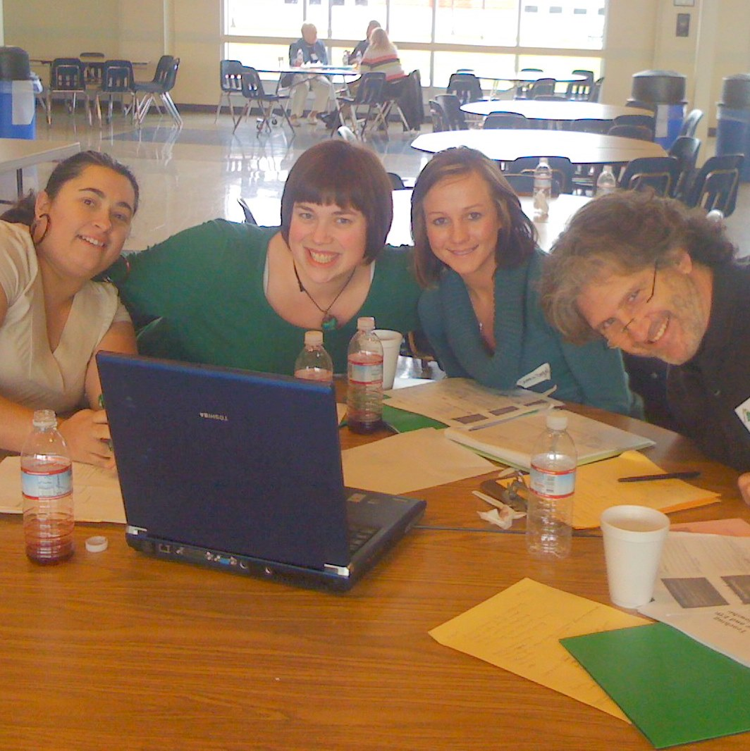

Sponsored by Southern Oregon ESD
101 North Grape Street
Medford, OR 97501

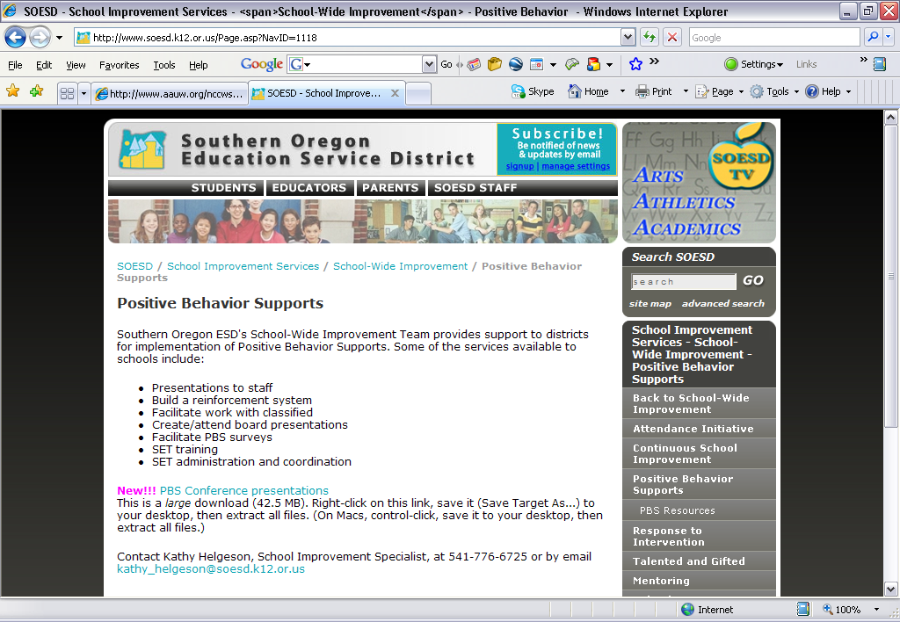
Registration
$50 per Person per Day Continental Breakfast and Lunch Included
Register at www.soesd.k12.or.us (Workshops & Prof. Development)

Bringing a team is recommended, and a team work time will be provided in conjunction with the lunch break. However, if you do not have a team, other sessions will be available during this time.

