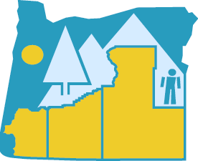
Southern Oregon ESD
Substitute Services

2019-2020 Pay Schedule

Hours Worked |  | Payday
August 1 - 31 |  | September 16, 2019
September 1 - 30 |  | October 15, 2019
October 1 - 31 |  | November 15, 2019
November 1 - 30 |  | December 16, 2019
December 1 - 31 |  | January 15, 2020
January 1 - 31 |  | February 14, 2020
February 1 - 28 |  | March 16, 2020
March 1 - 31 |  | April 15, 2020
April 1 - 30 |  | May 15, 2020
May 1 - 31 |  | June 15, 2020
June 1 - 30 |  | July 15, 2020

Checks mailed and not received have a waiting period of 5 days from payday before SOESD will reissue a check.

