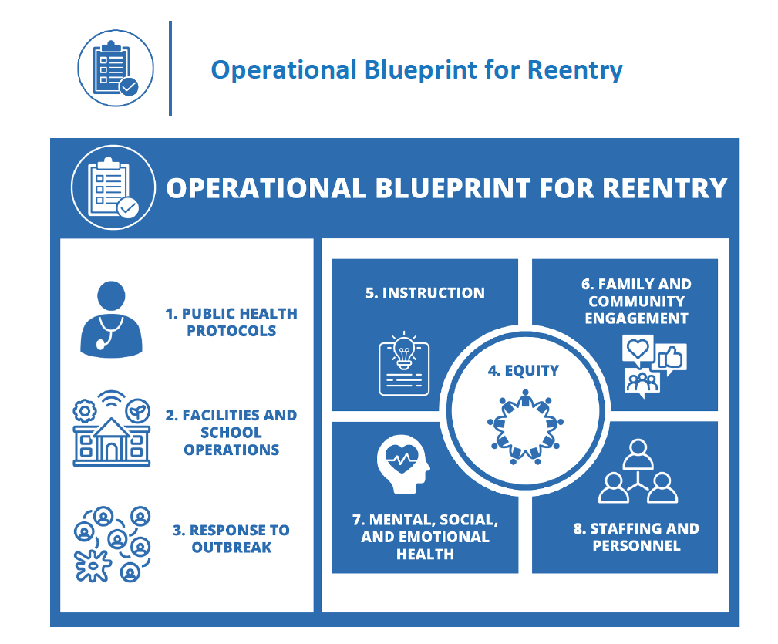

To live into an equity stance, Oregon schools must heighten attention to groups of students who bear the burden of an inequitable health and educational system. Through all of this work, educators must recognize the strengths and meet the needs of students of color, including students who are African-American/Black, Alaska Native and American Indian, Asian Pacific Islander, Refugee, Latino/a/x, Compact of Free Association (COFA) citizens, students who are emergent bilinguals (English Learners), students of migrant and farmworker families, students experiencing disability, students who are LGBTQ2IA+, students in foster care, students who have an incarcerated loved one, students experiencing houselessness, and students navigating poverty. It is not enough to make statements about equity without following those statements with concrete actions. Equity must live at the heart of every decision and every action in service of students.

Section 4: Equity
As you think about Equity, identify the specific ways you are prioritizing and elevating the needs of your historically underserved students, families, and staff.

 | What artifacts guide your thinking?  (Think about: surveys, stakeholder engagement opportunities, facilities data, enrollment data, empathy interviews) | What are my next steps?
What are some of the basic needs (e.g. food, shelter, clothing, mental/social/emotional health supports) and technology needs of our students with less access under each model of school reopening?

How will we use student and family voice to design learning spaces that are student-centered while meeting the requirements of sections 1-3? Which organizations in my community can help with outreach?

How will we create culturally responsive-sustaining spaces for our students and staff while meeting the requirements of sections 1-3 ?

How can we emphasize and prioritize relationships and building from student/family strengths in our district/school?

Section 6: Family and Community Engagement
As you think about Family and Community Engagement, identify the specific ways you are prioritizing and elevating the needs of your historically underserved students, families, and staff.

 | What artifacts guide your thinking?  (Think about: surveys, stakeholder engagement opportunities, facilities data, enrollment data, empathy interviews, and/or other processes) | What are my next steps?
How might you leverage community voice, collaborative partnerships, and data collected from recent processes and surveys to inform your district/school data?

What are our plans to engage families and communities in their primary languages? How will you stay in regular contact with families in their primary languages?

What is our plan for Tribal Consultation?

Section 7: Mental, Social, and Emotional Health
As you think about Mental, Social and Emotional Health, identify the specific ways you are prioritizing and elevating the needs of your historically underserved students, families, and staff.

 | What artifacts guide your thinking?  (Think about: surveys, stakeholder engagement opportunities, facilities data, enrollment data, empathy interviews, and/or other processes) | What are my next steps?
How will we address the challenge of keeping the emotional wellness and mental health of our students and staff centered in the work of our district?

Where might we need to build capacity in the 4 pillars outlined in the plan?

Trauma Informed Practices
Social Emotional Learning
Racial Equity
Strength Focused
How will we incorporate ongoing SEL instruction for all learners in our model?

In our SEL work, have we prioritized equity? Have we spent time understanding the potential pitfalls and recommendations for equity-centered SEL?

Section 8: Staffing and Personnel
As you think about Staffing and Personnel, identify the specific ways you are prioritizing and elevating the needs of your historically underserved students, families, and staff.

 | What artifacts guide your thinking?  (Think about: surveys, stakeholder engagement opportunities, facilities data, enrollment data, empathy interviews, and/or other processes) | What are my next steps?
Public Health Training
How will we ensure that there is effective training on health and wellness protocols for staff?

Identify time periods within your back to school week where professional development can be conducted.
Supports - High Risk Staff

Do we have procedures that are aligned with state and federal law that will assist us in supporting staff in high risk categories?

How do we ensure that leaders are trained in how to support these processes?
Professional Learning

What are the instructional needs of staff?

What training does staff need to address the needs of all learners in the new context?

Part 5: Instruction
As you think about Instruction, identify the specific ways you are prioritizing and elevating the needs of your historically underserved students, families, and staff.

 | On Site Model  (that considers short-term distance learning) | Hybrid Model  (that considers short-term distance learning) | Comprehensive Distance Learning Model  (that considers short-term distance learning)
What information do you already have that could inform your thinking on this model?

Think about: surveys, stakeholder engagement opportunities, facilities data, enrollment data

What further information or engagement do you need to inform your thinking on this model?

What are the implications for professional learning in regards to this model?

What are my next steps?

Balancing Health and Safety with Instructional Models
Public Health Measures  For each public health area below think through: | On Site Model  (that considers short-term distance learning) | Hybrid Model  (that considers short-term distance learning) | Comprehensive Distance Learning Model  (that considers short-term distance learning)
Communicable Disease Management Plan (1a)
Protocols should maintain rigorous health and safety practices

When developing a education practice infuse health protocols

After selecting any education practice or procedure, balance the risks of exposure with health mitigation procedures and adjust accordingly

Physical Distancing (1c)
Ensure that physical distancing can be employed during all location transitions (bathroom, lunch, recess, passing time, arrival and departure)

Reduce transitions to balance exposure or adjust schedules to limit interactions

Cohorting (1d)
Balance the risks of exposure by limiting transitions throughout the school day. The less stable the cohort the more risk of exposure

Outline all required staff engagements inside a cohort and eliminate non-essential staff who would typically provide service to multiple cohorts

Recognize the number of transitions and staff exposure to cohorts also increases the needs for cleaning and sanitation.

Response to Outbreak (3)
Develop procedures for teachers and students to quickly respond to an outbreak within all segments of the school day

Entry & Screening (1f)
When selecting your instructional model, consider how you will adhere to entry and screening requirements

Balance the risks of exposure and employ mitigation measures when developing entry procedures

Visitors & Volunteers (1g)

When selecting who is considered essential visitors/volunteer consider the impact they have on the crucial student learning objects as well as student wellness needs

Develop health mitigation procedures for all essential visitors/volunteer

Limit interactions with non-essential students

Isolation Measures (1i)

Be prepared at all school and office locations to immediately implement isolation measures

Infuse isolation procedures in all aspects of your education implementation protocols

RESOURCES:
Section 4:
Equity
Section 5: Instruction | Moving Beyond the Packet: Creating more Culturally Responsive Distance Learning Experiences (Zaretta Hammond)
Section 6:
Family and Community Engagement
Section 7: Mental, Social, and Emotional Health | Social Emotional Learning and Equity
Section 8: Staffing and Personnel

