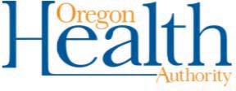

Notification: Exposure to COVID-19
Use this notification message to alert families when their child has been exposed to a positive case of COVID-19 or to alert Staff members when they have been exposed to a positive case of COVID-19.

Dear Parents and Families (or staff),

The health officials have worked closely with school officials to review cohort logs to identify individuals who may have been exposed to a person who tested positive for COVID-19. It has been determined that your child (you) may have had direct exposure to an ill person with COVID-19 symptoms/a person with a confirmed positive COVID- 19 case.

In consultation with the LPHA, we are immediately closing the following cohorts:
who will remain at home for 14 days under Comprehensive Distance Learning, with a tentative plan to return to in-person learning on (insert date).

It’s important to notify us If additional household members become ill with COVID-19. Additional protocols will be followed to ensure a safe return to school.

We know this is a hard time for everyone and our hearts go out to those who are ill. We will remain in contact with you to update the status of the school(s). Please check our school district webpage for updated information.

If you have questions, please contact .

