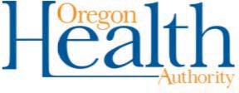

Phone Call (Pre-Recorded Message)

This is Superintendent (name) from (name) school district.

Recently, we were notified that a school district employee / student has tested positive for COVID-19. If you have not been notified that your child was in direct contact with an exposed person, they can return to school.

As members of the school community, we understand that this might raise concerns and questions about how this impacts your child and family.

We are working closely with [INSERT local health department] to respond to this news and protect the health of our community by temporarily closing [INSERT name of school here].

We have taken immediate action:

(list steps)

We care about the health and safety of our community.

For more information, visit the homepage of our website at .

