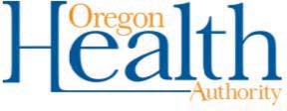

Script for Teachers / Staff - Positive Case at School

A positive case of COVID-19 was reported today (date).

This is difficult news and impacts all who are part of the (school / district) community.

While we are not able to share personally-identifiable information, we care about keeping our community informed.

Here’s what we know about the COVID-19 case(s) reported:

- On [date], an employee / student at [District / School Name] notified us of their positive test result for COVID-19.

- It has been days since the employee / student was last in contact with staff or students in our district.

- The individual(s) involved have been asked to stay home and self-isolate, as have any those who were in close contact.

The safety and well-being of our staff and students is our top priority. Our district has taken these action steps:
- They’ve contacted, and are working closely with, the Local Public Health Authority.

- They’ve contacted all person(s) who were in close contact with the individual.

- They’ve (closed the school building) and launched deep cleaning efforts.

- They’ve notified all students and families.

