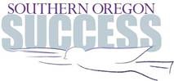

SOUTHERN OREGON SUCCESS UPDATE
January 2021

--One-Stop Referral for Parent/Guardian Education & Peer Support Groups

--Rogue Careers Website Launched: Career Pathways Set Out

--Financial Support for Businesses, Workers & Job Seekers

--OnTrack Rogue Valley Receives High Level Accreditation

--SOELS Promoting Protective Factors, Has Trainings & Family Engagement Toolkit Available

--Progress Being Made With “Raise Up Oregon”

--Community Information Exchange/Closed-Loop Referral System On Its Way

--Open ACES Training Sessions in January & February

--Join Us on Facebook

ONE-STOP REFERRAL SOURCE FOR PARENT/GUARDIAN EDUCATION & PEER SUPPORT GROUPS

The Family Connection, our region’s parent education hub, has generously agreed to keep a master calendar on their website that will include parent education and peer support groups for every organization in Jackson and Josephine counties that offer programs for parents and guardians.

The master calendar provides a consistent place for families to find information themselves or to be referred to by schools, doctors and others who work with children and families.

There are great courses, workshops, peer support groups and play-and-learn programs on the calendar, with more to come.

For more information on how to have offerings from your organization included on the calendar, please email Diana.Bennington@socfc.org

“I DIDN’T SIGN UP FOR THIS”—FREE ONLINE SUPPORT SESSIONS FOR PARENTING DURNG THE PANDEMIC

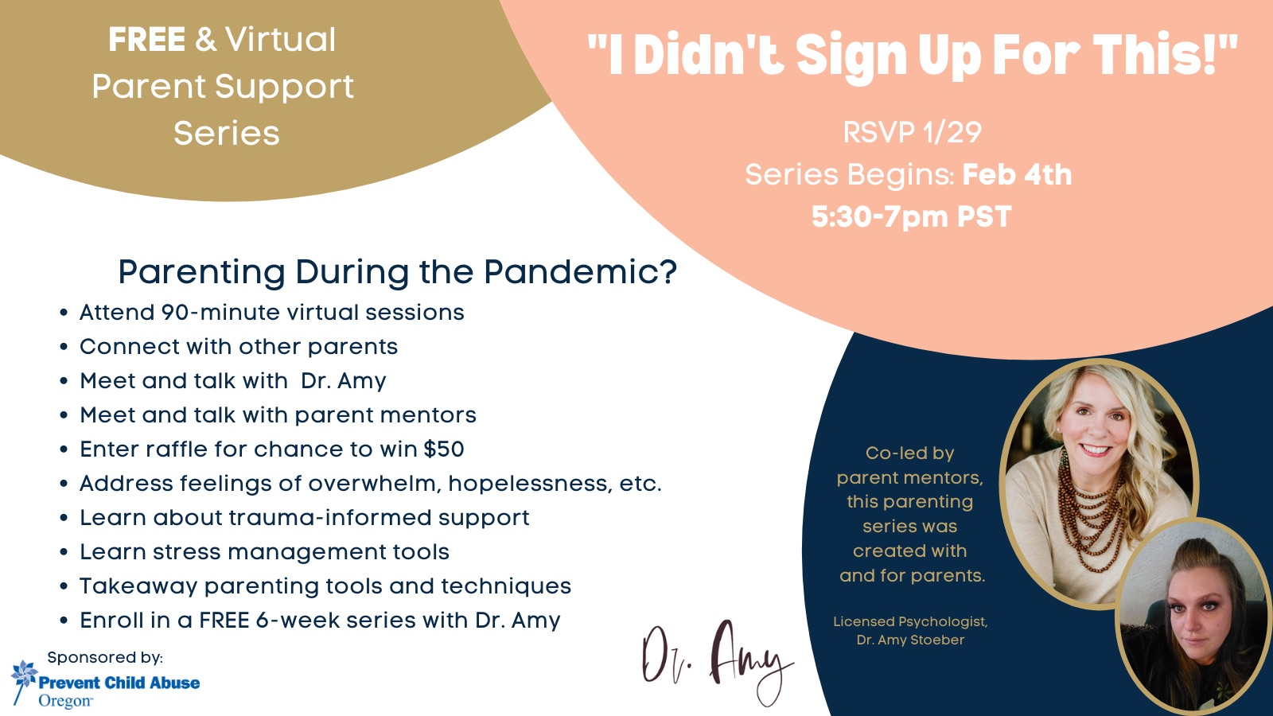

Register at: https://doctoramyllc.mykajabi.com/pcao_event

ROGUE CAREERS WEBSITE LAUNCHED—CAREER PATHWAYS SET OUT

A new Rogue Careers website has launched. It creates online career exploration support for job and career-seekers of all ages: students, their parents, under-employed or unemployed adults, laid-off workers, etc.

This one-stop site will link to all the region’s career exploration and career learning/on-boarding efforts. It has career planning resources and pages devoted to the region’s target industry sectors.

Check it out!

Rogue Careers Website

FINANCIAL SUPPORT FOR BUSINESSES, WORKERS & JOB SEEKERS

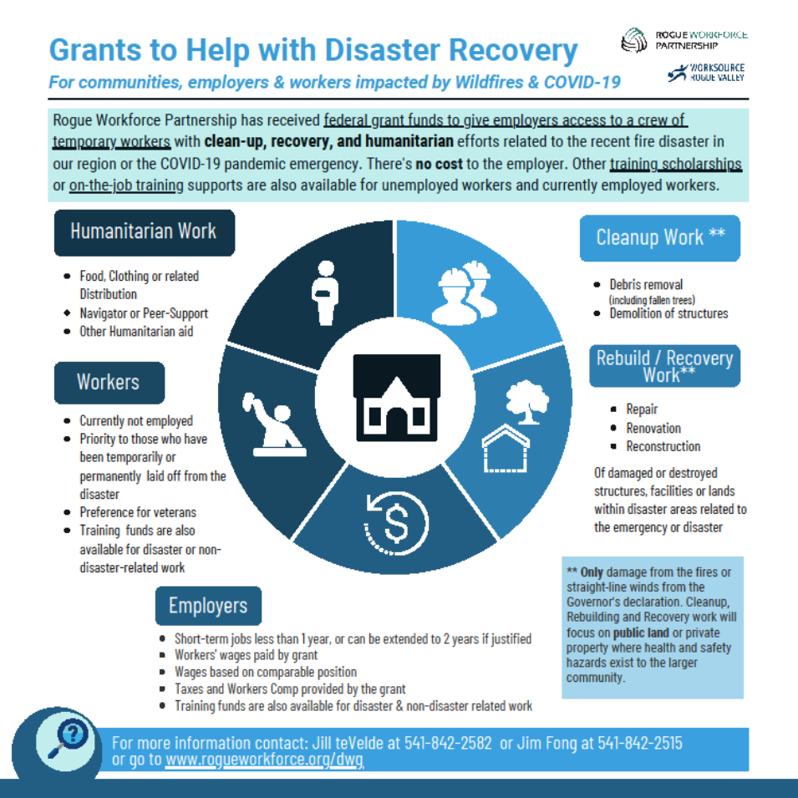

ONTRACK ROGUE VALLEY RECEIVES HIGH LEVEL ACCREDITATION

OnTrack Rogue Valley has announced it has received a three-year accreditation for all its programs and facilities from the Commission on Accreditation of Rehabilitation Facilities (CARF), an independent nonprofit accreditor of health and human services organizations.
The decision represents the highest level of CARF accreditation that can be awarded to an organization and shows a substantial conformance to CARF standards. An organization receiving a three-year accreditation has put itself through a rigorous peer review process and demonstrated to a team of surveyors that its programs and services are measurable, accountable, and of the highest quality.
OnTrack applied for CARF accreditation earlier this year, first completing a thorough self-evaluation that applied relevant CARF standards against the organization’s practices. A team of CARF auditors conducted an in-depth survey in November, interviewing staff, clients and community partners, observing organizational practices, reviewing documentation, and suggesting ways to improve the provider's operations and service delivery.
OnTrack currently has outpatient locations in Medford, Grants Pass and Cave Junction, and residential treatment facilities in Medford and Grants Pass.
About CARF
CARF is an independent, nonprofit accrediting body whose mission is to promote the quality, value, and optimal outcomes of services through a consultative accreditation process and continuous improvement services that center on enhancing the lives of the persons served.
CARF International (carf.org) currently accredits more than 60,000 programs and services at over 28,000 locations. More than 14 million persons of all ages are served annually by 8,000-plus CARF-accredited service providers. CARF accreditation extends to countries in North and South America, Europe, Asia, and Oceania.

SOELS PROMOTING PROTECTIVE FACTORS, HAS TRAININGS & FAMILY ENGAGEMENT TOOLKIT AVAILABLE

Southern Oregon Early Learning Services (SOELS) is committed to promoting protective factors as a proven way to offset the challenges many families in our community with young children are experiencing, including poverty, homelessness, behavioral health conditions, domestic violence, etc.

These challenges have been magnified with the impact of COVID and the fires across our region. SOELS is encouraging child and family-serving organizations to consider becoming Champions for Promoting Protective Factors with the following steps:

- Take the Strengthening Families Protective Factors Training contact Chelsea_Reinhart@soesd.k12.or.us for in-person training or visit https://www.prosolutionstraining.com/strengtheningfamilies/index.cfmfor the online training.

- Check out and use the new Family Engagement Tool Kit based on the protective factors that SOELS has developed. You can acquire the tool kit at no cost by emailing Chelsea at the email address above.

PROGRESS SHOWN FOR CHILDREN AND FAMILIES IN FIRST YEAR “RAISE UP OREGON” REPORT

“Raise Up Oregon,” our state’s ambitious five-year plan for all children and families to thrive, has completed its first year’s effort. Progress is being made in many areas, including increased access to high-quality preschool. There are still significant challenges in recruiting and compensating the early childhood workforce that Oregon needs. If you would like to read the report, you can find the highlights at this link and the full report at this link.

The work of SOELS and Southern Oregon Success is directly aligned with Raise Up Oregon, and the goals of the plan are being fully embraced by the Oregon Department of Education, the Oregon Health Authority, the Oregon Department of Human Services, and Oregon Housing and Community Services.

COMMUNITY INFORMATION EXCHANGE/CLOSED-LOOP REFERRAL SYSTEM ON ITS WAY

Building on the great work done over the last several years by the Rogue Hub, an expanded Community Information Exchange/Closed-Loop Referral System is being developed for our region through funding by AllCare and Jackson Care Connect.

The new system will use the Unite Us platform, which has been tested nationwide and found to be effective in connecting people to community resources. The Rogue Hub partner organizations plan to work with Unite Us to help develop an information and referral system that can be used by health care, human services, education, workforce development and others.

You’ll be hearing a lot more about this in coming months!

ACES TRAININGS COMING UP IN JANUARY & FEBRUARY

Open ACEs training sessions for new staff and anyone else interested will be held via Zoom on Tuesday, January 26 and Tuesday, February 16 from 2:30pm to 4:30 pm. To register for the January session, please go to this link. To register for the February session, please go to this link.

For more information, or to schedule a training session for your school, organization or community group, email peter_buckley@southernoregonsuccess.org

There is no cost to host a training or attend an open training, thanks to funding by our local school districts, SOESD, AllCare, Jackson Care Connect, Options for Southern Oregon, SOELS and Rogue Workforce Partnership.

JOIN US ON FACEBOOK

The Facebook page for Southern Oregon Success features almost daily postings of events taking place in our region and information shared from all over as part of our learning community efforts on what works and what doesn’t in helping kids and families thrive.

If you do Facebook, check us out and Like us at Southern Oregon Success.

If you do not wish to receive future Updates from Southern Oregon Success, please email peter_buckley@southernoregonsuccess.org with the subject line of “Unsubscribe”

JANUARY 2021

