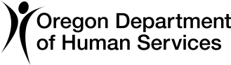
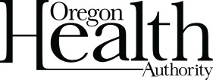
ODHS | OHA SHARED SERVICE
COVID-19 Response and Recovery Unit (CRRU)

Understanding your negative COVID-19 result
School instructions: The following information should be printed and provided to the parent or guardian of the student tested or the staff member tested.

Student name: Date of test:
Today, you/your student tested negative for COVID-19. This means that it is less likely that you/your student are infected with COVID-19. However, falsely negative test results may occur. It is still possible that you are infected with COVID-19.

If you/your student have symptoms consistent with COVID-19, please call your healthcare provider for additional information. Follow-up testing with a more accurate COVID-19 test may be recommended. You/your student may not return to school until all symptoms are improving and you/your student is fever-free for 24 hours without the use of fever-reducing medications.

If you/your student have had close contact with a person infected withCOVID-19 within the last 14 days, you may meet criteria as a “presumptive case” of COVID-19, even with today’s negative test result. Any person with symptoms compatible with COVID-19 who has had close contact with a case of COVID-19 within the last 14 days should contact their primary care provider or the local public health department at 541-774-8209 for additional instructions.

Your negative result will be reported to your local public health authority, but your test result will otherwise be kept confidential.

You can get this document in other languages, large print, braille, or a format you prefer. Contact the Coronavirus Response and Recovery Unit (CRRU) at 503-979-3377 or email CRRU@dhsoha.state.or.us. We accept all relay calls or you can dial 711.

1 of 1 OHA 3560D (01/19/2021)

