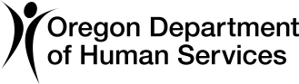
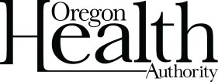
ODHS | OHA SHARED SERVICE
COVID-19 Response and Recovery Unit (CRRU)

Understanding your positive COVID-19 result
School instructions: The following information should be printed and provided to the parent or guardian of the student tested or the staff member tested.

Student name: Date of test:
Today, you/your student tested positive for COVID-19. This means that you/your student are infected with COVID-19. This is possible even if you/your student don't have any symptoms of COVID-19 or know anyone with COVID-19. Please call your healthcare provider for additional information regarding COVID-19.

Your positive result will be reported to your local public health department, but your test result will otherwise be kept confidential.

Whether or not you/your student have symptoms, stay home and separate yourself from others. COVID-19 may spread to others easily. Jackson County Public Health will be contacting you to go over instructions on isolation for yourself/your student and quarantine for any close contacts. Public health can also help link your family to services that are available to you/your student while in isolation or quarantine.

You can get this document in other languages, large print, braille, or a format you prefer. Contact the Coronavirus Response and Recovery Unit (CRRU) at 503-979-3377 or email CRRU@dhsoha.state.or.us. We accept all relay calls or you can dial 711.

1 of 1 OHA 3560C (01/19/2021)

