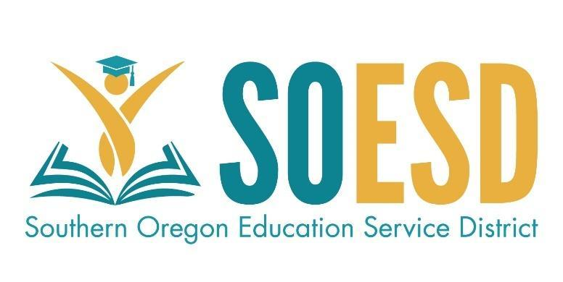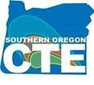

Southern Oregon Career and Technical Education Consortium
Handbook for CTE
2022-2024

Southern Oregon Education Service District
https://www.soesd.k12.or.us/cte/
Southern Oregon CTE and Career Connected Learning Directory
Introduction 2
Why CTE 3
Consortia Design 3
Consortium Membership 3
SOCTEC Members & Partners 5
Consortium Agreements 6
Roles and Responsibilities 6
Perkins V 10
Perkins Operational Calendar 10
Strategic Priorities and Goals 11
Fiscal Guide 11
Purchasing & Inventory Procedures 12
Professional Development 13
Reimbursement and Travel Guidelines 13
High-Quality Programs of Study 14
Teacher Licensure 16
Perkins Data and Accountability 16
Other Funding Sources 19

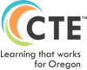

Introduction
Oregon’s Vision for CTE is: “Oregon will reimagine and transform learner experiences in order to enhance their future prospects, empower their communities, and ensure equity in an inclusive, sustainable, innovation-based economy.” It is the intent of the Southern Oregon Career and Technical Education Consortium (SOCTEC) to promote Oregon’s vision of CTE to all consortium members and partners.
SOCTEC promotes success for all students through quality Career and Technical Education programs that prepare students for the future workforce, meet industry standards, support collaboration among high school, post-secondary education, and business; and promote excellence in teaching. Our goal is that all students will receive appropriate and equitable access to and benefits from CTE. Our priority is to create quality relationships, experiences, and interactions among learners, educators, business partners, and community members
As SOCTEC works as a regional partner, we strive to keep the guiding principles of the Southern Oregon ESD as the focal point of our work: to provide services and leadership to optimize educational opportunities for the children, schools, and communities we serve.

Why CTE?
Career and Technical Education provides a unique model of educating students for career opportunities. Not only are teachers provided with cutting-edge equipment and technology, they come to the classroom with real-world experience and knowledge of their prospective career pathway. This allows them to create real-world experiences and connections with their students. Additionally, students who engage in CTE programs of study graduate at a higher rate and continue/complete post-secondary programs at a greater rate than their peers. According to the Oregon Department of Education, “Career and Technical Education participants (those students taking at least one CTE course) graduated at a rate of 90.8 percent in four years and CTE concentrators (students passing two classes in a CTE Program of Study) had a 94.8 percent graduation rate in four years,” https://content.govdelivery.com/accounts/ORED/bulletins/2ba5a80.

Consortia Design
In Oregon, various consortium arrangements exist, including those with and without community colleges. Each consortium uses its decision-making structure, but most operate with a group of member representatives who work with the Regional Coordinator and fiscal agent to efficiently, effectively, and appropriately expend Perkins dollars to improve Career and Technical Education across their regions. Community colleges and Education Service Districts serve as fiscal agents and employers of Regional Coordinators in Oregon. Consortium membership is a 12-month commitment from July 1 through June 30 of the following year.

Consortiums provide an opportunity for small school access to Perkins funds; stronger partnerships between secondary and postsecondary members; shared common work and professional learning for CTE instructors; less risk for not meeting performance measurements; and efficiencies gained in the administrative work associated with Career and Technical Education.

School districts and community colleges that generate more than $15,000 via the federal funding formula may also request permission from ODE to serve as their own fiscal agents and become direct grant recipients instead of consortium members. Direct grant recipients will still require the services of their CTE Regional Coordinator regarding teacher licensure and Program of Study or State Approved Program recommendations for approval and may also choose to purchase additional services. Direct grant recipients are responsible for their own grant applications, reports, and other Perkins requirements. Any school district or community college considering this option must notify ODE by February 1.

Consortium Membership
The Southern Oregon CTE Consortium area covers a 3-county geographic area serving 10 school districts, and two community colleges. Our region encompasses 10,579 square miles. We are made up of partner school districts and community colleges within Oregon’s Perkins Region 8 of southern Oregon. Consortium representation will be determined by district/community college leadership. Membership in this Consortium is voluntary. If a member wishes to withdraw they must notify the Regional Coordinator and request permission from ODE by February 1st
- Voting Membership: Each member organization is allowed 1 vote.
- Chairperson: Southern Oregon ESD’s Regional Coordinator or his/her representative will be the ex-officio head of the CTE Directors, will set meeting agendas, will chair all meetings, and will call special meetings when needed.
- Quorum: To have a quorum necessary to make decisions, at least 50% of the Consortium voting members or their temporary representatives must be present.
- Majority Vote: Decisions will be based on finding a mutually acceptable solution/group consensus whenever possible; however, it is agreed that if an issue must be determined by a division of the house, a simple majority of the votes possible for the number of members/proxies present will be binding on all parties.
- Removal/Changes in Governance: Any planned removal of a Member for failure to follow the assurances which are contained in this document and/or any planned change in the rules of governance of this Consortium must be presented in writing for a first reading and discussion at a regular meeting or a special one called in compliance with the procedure outlined in this document. The Regional Coordinator will present the written copy of this plan/change to all CTE Directors and the Member superintendents/president at least two weeks before the next meeting, at which time action may be taken on the measure. A simple majority of members/proxies of the quorum will be required to pass a removal or change in governance.
- Assurances Requirement: All decisions must be in conformance with the assurances, standards, and or/mandated guidelines set forth by the Federal Government pertaining to Strengthening Career and Technical Education for the 21st Century Act, the Oregon Department of Education, Oregon Revised Statutes and Oregon Administrative Rules.
- Meeting Dates: Meeting dates will be pre-scheduled and Members will be reminded of the meeting by email at least one week prior to the date. Should an emergency situation arise, a special meeting may be called by the Regional Coordinator.
- Renewal: This document must be reviewed and renewed by each member bi-annually.
- New Members: New Members will be added to this Consortium only when the voting CTE District Representatives reach an agreement to allow another school/district to become a Member of SOCTEC

SOCTEC Voting Membership Representatives are:
Member District/Organization | Voting Representation | Contact Email
Three Rivers School District | Casey Alderson | casey.alderson@threerivers.k12.or.us
Grants Pass School District | Trish Evens | TEVENS@grantspass.k12.or.us
Rogue River School District | Nicole Bambino | nicole.bambino@rogueriver.k12.or.us
Eagle Point School District | Traci Dulany | dulanyt@eaglepnt.k12.or.us
Butte Falls Charter School/District | Phil Long | plong@buttefalls.k12.or.us
Prospect Charter School/District | Payton Wolfe | paytonw@prospect.k12.or.us
Phoenix/Talent School District | Tami Ingwerson | tami.ingwerson@phoenix.k12.or.us
Ashland School District | Mark Miller | Mark.Miller@ashland.k12.or.us
Klamath City School District | Nat Ellis | EllisN@kfalls.k12.or.us
Klamath County School District | Tammy Ahalt | ahaltt@kcsd.k12.or.us
Klamath Community College | Chris Stickles | stickles@kcc.edu

SOCTEC Non- Voting Member Representatives are:
Organization | Representative | Contact Email
Rogue Community College | Kim Freeze | KFreeze@roguecc.edu
Klamath County Economic Development Association (KCEDA) | Randy Cox | randy@teamklamath.com
Rogue WorkForce Partners | Heather Stafford | Heather@rogueworkforce.org
Southern Oregon Regional Economic Development, Inc. (SOREDI) | Colleen Padilla | colleen@soredi.org
East Cascades Works | Heather Fitch | heather@ecworks.org

Consortium Agreements
Consortium agreements are sent to partner districts and community colleges annually in April and are due to the Southern Oregon ESD by May 15 of each year. Consortium agreements are linked here - High School Agreement; Community College agreement; MOA - for schools outside of SOESD local service plan area.

Roles and Responsibilities
CTE Regional Coordinators serve as the primary leadership lever in the field. Oregon has a long history of leveraging regional leadership structures to ensure teachers and students are afforded consistency in the CTE experience. Each of the 17 CTE Regions in the state have a CTE Regional Coordinator employed by a local college, ESD or school district to serve on behalf of the region, coordinate CTE activities and are responsible for Perkins consortium grants. While some view the CTE Regional Coordinator as a secondary-focused individual, many serve as the college liaison or even the Community College Leader for CTE.
Southern Oregon ESD/CTE Regional Coordinator supports CTE on a regional basis by:
- Providing a copy of the consortium agreement to each member, updated annually
- Convening SOCTEC member districts monthly or as needed
- Representing SOCTEC with ODE and at statewide CTE meetings
- Completing and submitting CTE Program of Study Applications in partnership with consortia districts
- Completing and submitting Perkins Annual Reports in a timely manner
- Completing and submitting Perkins Grant Applications (every four years with yearly update) and Budgets (annually) in a timely manner
- Coordinating and administering the appropriate expenditure of Perkins funds
- Overseeing the CTE licensure process of CTE teachers in conjunction with partner districts
- Works with high schools and community colleges to coordinate high school/ postsecondary articulation agreements
- Facilitate collaboration and articulation between community colleges, apprenticeship programs and the workforce
- Promote the collection and use of student and program data in the decision-making process
- Promote involvement in both the state and national Career and Technical Education associations
- Coordinating Program of Study meetings for secondary and postsecondary instructors
- Providing technical assistance with CTE End of the Year report and annual update
- Interacting with business and industry partners on behalf of consortium members
- Maintaining inventory list of all Perkins-purchased equipment and software
- Collaborate with the SOESD School improvement staff
Consortium District Superintendent
- Appoints / authorizes an individual from their district to serve as a District CTE Representative to SOCTEC.
- Works in collaboration with the SOESD, district high school principals and administration to ensure the highest quality of CTE POS.
- Supports and promotes CTE POS at all levels of public education.
- Authorizes Consortium membership by signing the Consortium Agreement with Assurances before any Perkins funds are expended.
- Should be familiar with this handbook and the changes in Perkins V.
Secondary Administrators and Community College Dean's support CTE programs in their schools by:
- Complying with federal, state and if applicable local assurances and fiscal requirements
- Overseeing the professional development of CTE instructors and ensuring they are meeting requirements before expending funds
- Supporting Data Personnel in collecting and completing CTE Course and Student Collection as well as Program Update and complying with all data requirements
- Assuring that all CTE students have the opportunity to participate in Work-Based Learning opportunities within or outside of the school day
- Meeting all requirements of Title IV - Civil Rights

Voting Consortia District Directors/Representatives
- Should be familiar with this handbook and the changes in Perkins V law.
- Attend monthly Southern Oregon Carl Perkins Consortium, SOCTEC meetings and serve as the primary point of contact between SOCTEC and their district and schools.
- Represent your district and the region by participating in relevant discussions with regard to planning, goal setting, strategizing, and any other endeavors for improving all aspects of CTE.
- When possible, attend conferences/professional development related to CTE and their service as a representative.
- Regularly communicate important and pertinent information received at Consortium or related meetings, conferences, or PD opportunities, to appropriate administrative and all district CTE staff and support personnel.
- Provide guidance to CTE teachers, administrators, and other colleagues that will help them understand what is developing within our region and around the state with regard to CTE.
- Coordinate, administer, and help ensure the appropriate expenditure of Carl Perkins funding.
- Help facilitate a viable inventory of and track any equipment purchased with such funds (any non-consumable that exceeds a purchase price of $200.00) Reference Section 135 of Perkins federal, state, and local guidelines.
- Ensure completion of and submit CTE-required program and data reports in a timely and accurate manner.
- Assist with CTE Program Approval and CTE Teacher Certification issues within your schools.

Non-Voting Consortia District Directors/Representatives
- Should be familiar with this handbook and the changes in Perkins IV.
- Attend monthly Southern Oregon Carl Perkins Consortium, SOCTEC meetings and serve as the primary point of contact between SOCTEC, their post-secondary institution, or their related business and industry concerns.
- Participate in relevant discussions with regard to planning and strategizing regional efforts on behalf of CTE.
- Attend conferences/professional development related to CTE and their service as a representative.
- Communicate information received at Consortium meetings and subcommittee meetings to appropriate administrative, support, or collegial staff.
- Provide guidance to CTE teachers in their schools and other colleagues that will help them understand what is developing within our region and around the state.
- Any other overlapping function in the aforementioned voting representative responsibilities.

Secondary and Postsecondary Instructors support students in their CTE programs by:
- Providing rigorous instruction and assessment aligned to the appropriate academic and technical skills that students need in order to be prepared for high wage, high demand occupations in their field
- Complying with federal, state and if applicable local assurances and fiscal requirements
- Working with CTE colleagues to strengthen secondary-postsecondary partnerships
- Maintaining licensure requirements and keeping license current
- Pursuing opportunities for students that will contribute to their college and career readiness (i.e. dual credit, CTSOs, career-related learning and applied academics)
- Participating in professional development focused on improving CTE programs and/or Perkins performance measurements
- Providing diverse Work-Based Learning opportunities for all students within their program
- Engaging with industry partners and convening Advisory Committees at least twice yearly
For additional information, reference page 19 in the Oregon CTE Policy Guidebook (Download ODE Guidebook to SOESD-CTE Page and link)

Perkins V
On July 31, 2018, the President signed the Strengthening Career and Technical Education for the 21st Century Act into law. This bill reauthorizes the Carl D. Perkins Career and Technical Education Act of 2006 (Perkins IV) and is referred to as Perkins V.
Perkins V reflects the 100-year federal commitment to Career Technical Education (CTE) by providing federal support for CTE programs and focuses on improving the academic and technical achievement of CTE students, strengthening the connections between secondary and postsecondary education and improving accountability. Perkins V affords states and local communities the opportunity to implement a vision for CTE that uniquely supports the range of educational needs of students — exploration through career preparation — and balances those student needs with the current and emerging needs of the economy.

Perkins Operational Calendar
May 15 | Perkins Funding (initial) requests due to SOCTEC/SOESD for new school year – CTE District Representative
May 15 | Biennial SOCTEC Perkins Asset Inventory review in even years – CTE District Representative/ SOCTEC staff
June 15 | Budget approved by regional budget committee - SOCTEC
June 30 | Perkins Basic and Reserve Action Plan and Budget Due - CTE Regional Coordinator
June 30 | Biennial review of consortium handbook in even years - SOCTEC
June 30 | All Renewing POSs applications are Due - CTE District Representative/ CTE Regional Coordinator
June 30 | All New POS applications are Due - CTE District Representative/ CTE Regional Coordinator
June 30 | ODE CTE Spring Collections Report is Due to ODE – CTE District Representative/District Data Reporter
July 1 – Mid July | If approved, 20% Perkins V Grant Funds becomes available
August (end of second week) | All high school Career Pathways Awards must be claimed by individual district business offices
Early Sept. | Program of Study Update opens for high school partners – CTE District Representative/District Data Reporter
October 1 | If approved, remaining (80%) of consortia’s Perkins allotment becomes available
Mid Oct. | Program of Study Updates closes for high school partners - CTE District Representative/District Data Reporter
Nov. SOCTEC meeting | ALL Perkins Purchase Requisitions due to SOESD, remaining funds will be rolled into 23-24 Perkins Mini-Grants for re-distribution to consortia
Nov. 15 | Fiscal Reporting for previous year grant – CTE Regional Coordinator
Dec. 15 | All Perkins Approved Purchases received and on-site at each POS
June 30 | ODE CTE Spring Collections Report is Due to ODE – CTE District Representative/District Data Reporter
3rd Thursday of Sept - May | Monthly SOCTEC Meetings
Twice Yearly | Program of Study Meeting by Career Cluster

Strategic Priorities and Goals (link with new -2023 -CTE/STEM Regional Strategic Plan when completed summer of 2023)
Following guidelines from the Oregon Department of Education, the Southern Oregon Career and Technical Education Consortium will convene a group of stakeholders on a biennial basis to create a strategic plan and priorities. The stakeholder group will include administrators, teachers, students, parents, industry partners, the workforce investment board and economic development staff. For the 20-24 Perkins Grant, our strategic priorities are as follows:

Update in June 2023 to reflect consortium districts’ Integrated Guidance strategic plans and college’s 4-year goals
  - Strengthen Work-Based Learning Opportunities for students
  - Increase Counselor Engagement and Support of CTE program of study
  - Improve Access and Equity for ALL students in CTE program of study
  - Strengthen Industry Alignment and/or Engagement
  - Increase or support Middle School/High School/Postsecondary Alignment of program of study

Fiscal Guide
Detailed fiscal guidance is available in the Oregon CTE Policy Guidebook (download to SOESD-CTE page and link) starting on page 129.
Perkins funding follows a 15-month grant period from July 1 - September 30. Each Spring federal, state and local entities gear up to distribute Perkins funds for planned activities that improve programs. As each fiscal year grant cycle comes to a close, the state collects annual reports from local eligible recipients. These reports serve as the official record of accountability for the appropriate use of Perkins funds and provide the basis for Oregon’s Consolidated Annual Report (CAR) to the federal Office of Vocational and Adult Education (OVAE). Consistent inability to address weak performance may interrupt the flow of funds to local programs. Perkins funds will be used for program improvement and enhancement and will supplement programs of study, not supplant.
The Southern Oregon Career and Technical Education Consortium, along with a stakeholder engagement committee, will determine local strategic priorities that will be used for budgeting. As a program of study groups, secondary and post-secondary instructors, in concert with their advisory committees, determine programmatic needs and align them to the strategic priorities. Funds do not flow through to individual schools, districts, or community colleges. The Southern Oregon ESD will make all allocable expenditures on behalf of eligible programs of study. All budget items will be approved by the Oregon Department of Education CTE Grant Managers before any purchases are made. To the best extent possible, all items purchased must be made in the USA.

Purchasing Procedures
Only equipment approved by the consortium and the ODE/CTE Grant Managers may be purchased. All purchasing will be completed by the Southern Oregon ESD to ensure that all federal purchasing and inventory procedures are met and that technology purchases are compatible with a school’s networking and service agreements.
- If funds are to be braided with other funds from within a consortia member, all purchases will be made by the Southern Oregon ESD and be billed to the consortia member, regardless of the percentage split.
- All Perkins purchases will meet the written policies and procedures within the Southern Oregon ESD Business Office, and remain a part of the SOCTEC Asset Inventory.

Inventory Requirements
- All equipment (object code 0460 and over $200), capital equipment (object code 0541 and $5,000 and over), and computer hardware (object code 0470) purchases must be added to Perkins Inventory and marked with a SOCTEC asset tag.
- An inventory list must be provided to the SOESD CTE department each spring and include purchase date and cost; model, serial number, and or other identifying information; location in the building (i.e. program use); and disposition (condition).
- Districts are responsible for the maintenance and liability of all items listed on their Carl Perkins inventory. Please ensure that all high-theft items (i.e. cameras, iPads, etc.) are stored in a locking cabinet and accounted for regularly.
- Once the items expire from the district Perkins Inventory list, those items may be used or discarded according to local district policy and wishes. Districts are expected to offer unwanted CTE equipment to other members of the Perkins Consortium.
- If inventoried items are no longer needed in an “approved” CTE program within the district before they expire from the inventory list, those items must be offered to the consortium. If no other member district can use the item for an “approved” CTE program and the Perkins budget committee approves, the item can expire from the district Perkins inventory and can be used or discarded according to local district policy and wishes.
- In the case that a consortium district member chooses to withdraw from the consortium: SOCTEC recommends that all consortium-owned equipment currently assigned to a departing district remain in that district with reimbursement provided to the consortium at fair market value, or be returned to the consortium for redistribution among remaining members.
- Be prepared for unannounced inventory spot checks.

Professional Development

Professional development is an integral part of the Perkins V Act. Following state guidelines, no less than 15% of the total allocation made to the Southern Oregon ESD will be dedicated to professional development applicable to each teacher and CTE program of study. This will include, but is not limited to, program of study meetings, alignment to industry standards and postsecondary programs, etc. In coordination with their advisory committee and administration, CTE teachers will identify professional development needs and request funds through the regular Perkins Budget cycle. Teachers may be eligible for a stipend if they are engaged in professional development outside of their contract day. The maximum stipend amount per eight-hour day shall follow the agreed-upon substitute rate, set by the SOESD Business Manager and the business managers of the consortium districts, every year. All stipends will be approved before professional development activities and will be paid out, first, by the consortium district, which will in turn invoice the SOESD for reimbursement. Follow all reimbursement and travel guidelines for professional development that require registration and/or travel. Add link to the SOESD-CTE web-page

Reimbursement and Travel Guidelines
Please read and follow the reimbursement and travel guidelines. (download ODE Policy Guidebook to SOESD-CTE page and link pages 125, 126, & 127, and “Section 14 Financial Requirements”) All travel must be approved by the CTE Regional Coordinator prior to travel. Please coordinate registration and expenses with the CTE Administrative Assistant.

High-Quality Programs of Study
Please reference the Oregon CTE Policy Guidebook for additional information and references. SOCTEC will follow the statewide CTE Program of Study Transition Schedule created by the Oregon Department of Education.
Download the Oregon CTE Policy Guidebook, load it onto the SOESD-CTE page, so that we can then provide direct links to the guide and page #s that apply to the guidance in the SOCTEC Handbook
In Oregon, the CTE Program of Study is the cornerstone of CTE programming. In the Perkins V Act, the term “program of study” means a coordinated, non-duplicative sequence of academic and technical content at the secondary and postsecondary level that:
- incorporates challenging state academic standards;
- addresses both academic and technical knowledge and skills, including employability skills;
- is aligned with the needs of industries in the economy of the state, region, or local area;
- progresses in specificity from a broad overview at the Cluster level to occupation-specific instruction at the Focus Area (Pathway) level;
- has multiple entry and exit points that incorporate credentialing; and
- culminates in the attainment of a recognized postsecondary credential and/or degree.
Oregon achieves the federal definition of a High-Quality Program of Study by requiring five core elements essential to every state-approved CTE Program of Study in the state:
1. Standards and Content
2. Alignment and Articulation
3. Accountability and Evaluation
4. Student Support Services
5. Professional Development

Oregon adopted a CTE Program of Study Quality Rubric built around these five core elements and aligned them to the national Association for Career and Technical Education’s (ACTE) High Quality CTE Program of Study framework. This rubric is to help local programs evaluate the health of their CTE Programs.
The SOCTEC CTE Regional Coordinator will regularly convene a program of study groups following professional learning community frameworks. PLC groups will meet at least twice yearly and will focus on program improvement, implementation of CTE standards, integration of applicable core curricular standards, and collaboration with fellow CTE instructors at the secondary and postsecondary levels.

For CTE administrators, it is important to understand the elements of an Oregon CTE High Quality CTE Program of Study to help ensure that an institution’s CTE is meeting the needs of students as well as those of business and industry. The Oregon Department of Education has provided a Quick Guide to High Quality CTE POS. Below is a high-level overview of the five core elements of a High Quality CTE Program of Study.
1. Standards and Content
a. Rigorous Integrated Content: CTE students have access to rigorous core academic coursework relevant to their career interests and the opportunity to apply academic, technical, and professional skills in both CTE courses and academic courses.
b. Engaged Learning: Learning is centered on the student’s interests, strengths, and needed areas of growth. Engaged learning involves opportunities to engage in meaningful projects connected to the community and is supported by the school, college, and community. Assessment of learning addresses industry-based standards and provides feedback to students and instructors that drives program improvement.

2. Alignment and Articulation
a. Partnerships: Formalized agreements exist with partners, including secondary and postsecondary education institutions, business and industry, and workforce development, around program development, design, implementation, and evaluation.
b. Credentials: CTE Program completers can participate in work-based learning opportunities and earn industry recognized credentials, certificates, and degrees that increase their employability and ability to advance in their career of choice.
c. Facilities and Equipment: CTE Programs maintain equipment that meets industry standards, and facilities follow safety and cleanliness standards of the industry and create a safe, welcoming, and accessible environment so all students may participate.

3. Accountability and Evaluation
a. Continuous Improvement: Schools and institutions that have participating CTE Programs collect and submit CTE data to the state. These data points are frequently used to inform instruction. Programs are continually revised based on employer demand and industry needs, as well as student participation and performance.

4. Student Support Services
a. Career Development: There is a coordinated and sequenced career development system to support students before, during, and after participation in the CTE Program. Each CTE student has a personalized career and education plan, and parents and CTE students are informed of opportunities for CTE education and training in high school, college, apprenticeships, and other opportunities.
b. Education for Employability: Students develop employability skills through classroom and course aligned work-based learning opportunities. Students actively develop leadership skills through student leadership opportunities (e.g., Career and Technical Student Organizations, or CTSOs) tied to the CTE Program.
c. Access and Equity: CTE Programs are a central part of the school’s equity strategy, and demographics in CTE mirror school demographics and positively impact local industry representation of underrepresented groups. CTE student outcomes contribute to the elimination of opportunity gaps and institutional discrimination.

5. CTE Professional Development: Each CTE educator has a professional development plan in place. The plan is developed with input from industry and community partners and includes goals, plans, and participation clearly aligned to documented CTE Program goals. Any professional development plan adjustments reflect the continuous improvement design of the CTE Program of Study.

Teacher Licensure
To teach in an Oregon state approved CTE program of Study, the instructor must have an appropriate CTE license and/or endorsement that is specific to the program career area. CTE Licensure is a two-step process that starts with the CTE Regional Coordinator. The Oregon Administrative Rules (OARs) governing CTE teacher licensure were revised and adopted by the Oregon Teacher Standards and Practices Commission (TSPC) in 2010. Chapter 584 of the OARs (see appendix A) includes those rules specific to TSPC. Division 42 is the section of OARs under TSPC regulation that outlines CTE Licenses and Endorsements.

Perkins Data and Accountability
Following Perkins V, Oregon recognizes and reports on eight secondary and three postsecondary core performance indicators. Data is to be reported yearly by consortia partners, both secondary and postsecondary, and will follow the data guidance posted by ODE, and posted to the Oregon Data page. Individual, District and Program of Study Level Performance Measurement Data may be accessed through the ODE District site.
Secondary Definitions
- CTE Concentrator - A secondary CTE concentrator is a student who earns at least two credits in a single CTE Program of Study. One of those credits must be earned through a course or courses identified as intermediate or advanced.
- Course Level Descriptors
  - The secondary CTE concentrator definition includes a course-level descriptor. The descriptor emphasizes the importance of creating a course sequence within a CTE Program of Study. National research has demonstrated the positive impact of CTE on student outcomes when taught through a sequence of courses rather than a number of loosely connected electives. Under Perkins V, course-level descriptors will be:
    - Introductory Course – A course that focuses on raising career awareness and learning basic professional and technical skills associated with the CTE Program of Study. The course helps develop student interest rather than technical proficiency in a CTE Program of Study.
    - Intermediate Course – A course that focuses on exploring careers and learning specific technical and professional skills. The course builds on basic skills and moves toward technical proficiency in preparation for a career.
    - Advanced Course – A course that focuses on preparing for a career and refining specific technical and professional skills. The course integrates multiple skills through project-based instruction and/or work-based learning. These courses focus on preparing students for entry-level work or postsecondary programs.
- Secondary Performance Indicators and Definitions
  - 1S1: Four-Year Graduation Rate - The percentage of secondary CTE concentrators who graduate within four years. This indicator uses the same definition for a high school graduate as the one used to determine overall state four-year graduation rates.
  - 1S2: Extended Graduation Rate - The percentage of secondary CTE concentrators who graduate within five years. This indicator uses the same definition for a high school graduate as the one used to determine overall state five-year graduation rates.
  - 2S1: Academic Proficiency in Reading/Language Arts - The percentage of secondary CTE concentrators who demonstrate proficiency in reading/language arts as measured by the statewide assessment. This data is reported in the year that the student takes the assessment. In Oregon, statewide assessments are administered during 11th grade.
  - 2S2: Academic Proficiency in Mathematics - The percentage of secondary CTE concentrators who demonstrate proficiency in mathematics as measured by the statewide assessment. This data is reported in the year that the student takes the assessment. In Oregon, statewide assessments are administered during 11th grade.
  - 2S3: Academic Proficiency in Science - The percentage of secondary CTE concentrators who demonstrate proficiency in science as measured by the statewide assessment. This data is reported in the year that the student takes the assessment. In Oregon, statewide assessments are administered during 11th grade.
  - 3S1: Postsecondary Placement - The percentage of secondary CTE concentrators who, in the second quarter after exiting from secondary education, are in postsecondary education; are in advanced training, military service, or a service program; or are employed.
  - 4S1: Nontraditional Program Enrollment - The percentage of CTE concentrators in CTE Programs and Programs of Study that lead to fields that are nontraditional for the gender of the concentrator. These programs are identified using national data.
  - 5S3: Program Quality – Participation in Work-Based Learning - The percentage of CTE concentrators graduating from high school having participated in work-based learning.

Postsecondary Definitions
- Postsecondary CTE Concentrator - A postsecondary CTE concentrator is a student who has earned at least 12 credits, of which nine program credits are CTE specific, within a CTE Program or Program of Study, or completed the program if it is fewer than 12 credits.
  - 1P1: Postsecondary Placement - The percentage of CTE concentrators who complete a program and then continue in postsecondary education; are in advanced training, military service, or a service or volunteer program; or are placed or retained in employment.
  - 2P1: Earned Recognized Postsecondary Credential - The percentage of CTE concentrators who received a recognized postsecondary credential during participation in or within one year of program completion.
  - 3P1: Nontraditional Program Concentration - The percentage of CTE concentrators from underrepresented gender groups who participate in CTE Programs and Programs of Study that lead to nontraditional fields.

Other CTE and STEM Funding supports
With the explosion of new CTE programs in the state, additional funding sources have become available to school districts across the state. Many of these sources may be braided with Federal Perkins funds to help build, grow, enhance, and supplement CTE Programs of Study.
SOCTEC will continue to work closely with its partner districts/schools, the SOESD School Improvement Career Connected Learning (CCL) and STEM Hub Team, Southern Oregon Regional Economic Development Inc. (SOREDI), Klamath County Economic Development Agency (KCEDA), our Central Oregon and Rogue WorkForce and Industry partners to source, and braid, expanded funding as it becomes available to expand and support CTE students and regional CTE Programs of Study.

STEM Initiatives
There are a variety of STEM Investment funds available to local schools, districts, and regional STEM Hubs.
High School Success/M98
High School Success is a fund initiated by ballot Measure 98 in November 2016. The measure passed with 65% voter support and allowed the Oregon Department of Education (ODE) to disperse $170 million total during the 2017-19 biennium among districts and charter schools that serve students in grades 9 through grade 12.
During the first year of implementation (2017-2018), 255 school districts and charter schools throughout the state of Oregon received the first allocation from the High School Success fund.
During the second biennium (2019-2021), 252 school districts, charters, YCEPs, and JDEPs throughout the state of Oregon benefited from funds through the creation of 230 High School Success plans.
Funding is provided to establish or expand programs in three specific areas:
- Dropout Prevention
- Career & Technical Education
- College-Level Education Opportunities
Secondary Career Pathways
The Secondary Career Pathways Funding was established by the Oregon Legislature through HB 3072. This is a first attempt at a sustained funding source for Career and Technical Education (CTE). It is intended that the funds allocated through this program will incentivize intensive CTE Programs of Study that lead to high wage and high demand occupations.
CTE Revitalization
The CTE Revitalization Grant program is a purposive concept designed to support student engagement and success, with completion leading to career and college preparation, and a potential boost to local/regional economic development.
For additional information, visit the following links:
- https://www.oregon.gov/ode/learning-options/CTE/Pages/default.aspx
- https://www.acteonline.org/
- https://careertech.org/

SOCTEC Region 8 Consortium Assurances (2023-2024 School Year)

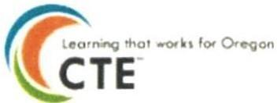
OREGON
DEPARTMEN T DF

EDUCATION
-
SOCTEC Region 8 Consortium Member Assurances
As a member of the Region 8 consortium I/we agree and commit to:

- Provide and ensure the regular participation and attendance of a representative on the Southern Oregon Career Technical Education Consortia (SOCTEC), to include: regular monthly meetings, and ongoing collaboration with all district CTE instructors and their Programs of Study (POS).
- Supporting the efforts of district CTE teachers and POS to provide quality and meaningful instruction (relevant and rigorous content, a safe and engaging environment, and qualified staff) by ensuring that:
  - Local planning and funding requests will reflect the priorities set forth by the Carl D Perkins CTE Act of 2006. and the ODE State Plan for Career and Techn ical Education 2021-2022
  - Funds will be expended for grades 9-14 approved Programs of Study (POS) to improve, enhance, expand, or supplement, but cannot be used to maintain or sustain POS.
  - There is course and program alignment to industry standards and post -secondary education or career opportunities.
  - There is rigorous academic content, dual credit when possible, equitable access to all students. continuous improvement using quality data, student support at multiple levels. professionally developed and appropriately licensed instructors, opportunity for student leadership and quality assessment of student academic and technical skills achievement.
- Expenditures will comply with the federal Perkins Section 135, state and local guidelines, regarding the purchase, use, disposal & inventory procedures outlined in the Fiscal Guide section of the consortium handbook. As all equipment purchased with Perkins funding belongs to the consortium, if a POS is discontinued members of the consortium will determine its future allocation and use.
- All of the reporting and data collections required by the ODE will be furnished by established deadlines, including the Annual Fall Program Update and the Spring Data Report. Support and concerted effort and consideration will be made to identify and re­ test CTE 11th and 12 ^{th} grade Concentrators who have yet to meet the OAKS (state standards) for reading, writing and/or math.
- Support the consortium's efforts to invest 15% of our Perkins allocation for professional development of teachers and staff that directly support their efforts .

Carl D. Perkins Career and Technical Education Act of 2006 & the Strengthening Career and Technical Education for the 21st Century Act (Perkins V) Statement of Assurances
This assurance must be submitted before local consortium allotments are released :
DocuS1gn Envelope ID: C0873923-C5FA-45BF-81CF-2CBF011 C72B4

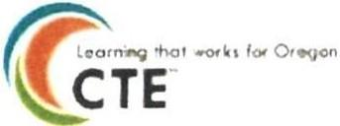
OREGON
lit
DEPARTMENT OF

EDUCATION

By my signature, I am assuring that in my buildings:
- We will comply with the provisions, regulations, and rules of the Carl D. Perkins Career and Technical Education Act of 2006 and the Strengthening Career and Technical Education for the 21st Century Act (Perkins V).
- We will use federal funds to supplement the buildings CTE Programs of Study and will not use federal funds to supplant existing funds or reduce general or other funds.
- We will provide, on request, complete and accurate data as required.
- We will comply with all applicable assurances for Federal Grant Funds.
- Funds will be expended for grades 9-14 Programs of Study which meet Foundation Criteria : Aligned to careers, equitable access, Aligned to CTE standards, Continuous Improvement, and Appropriately (TE-licensed instructors.
- That expenditures will comply with the federal Perkins Section 135 and other state and local guidelines, including the purchasing & inventory procedures outlined in the Fiscal Guide of this handbook;
- That all of the reporting and data collections required by the Oregon Department of Education will be furnished by established deadlines, including assisting the Regional Coordinator with the Annual Program Review in the Fall, and submitting program data collection in the Spring.
- Will give the regional coordinator access to confidential and personally identifiable student data relating to the implementation of career and technical education programs.
- That State & Federal Assurances will be followed; and
- . That the local budget will reflect the following priorities set forth by the Southern Oregon Career & Technical Consortium (SOCTEC) and required by the Carl D. Perkins Career & Technical Education Act of 2006, the Strengthening Career and Technical Education for the 21st Century Act (Perkins V}, and the Oregon State Plan 2020-2024 :
  - To improve and/or supplement "approved" 9-12 Programs of Study, or the Development of middle school career exploration and training
  - To invest 15% of our building Perkins allocation in professional development
  - To demonstrate strategic investment by utilizing funds for programs whose teachers are actively working to improve their Programs of Study by: attending appropriate professional development, providing opportunities for student leadership, providing secondary and post-secondary content (articulation of credits when possible), and working towards a standards­ based program of integrated academic & technical skill content culminating in a technical skills assessment.


OREGON
OEPRRTMENT OF
EDUC ATION
(? .....,.-,.
CTE

I have read and agree to comply with the stipulations addressed in this document.

Name of Member District: Ashland School Dis t rict

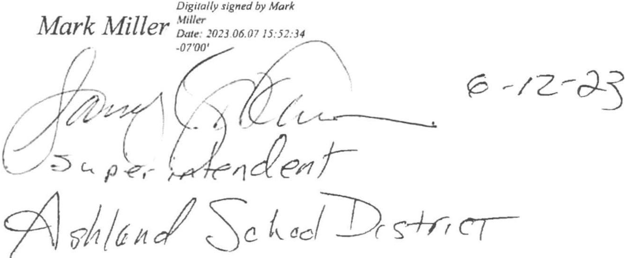

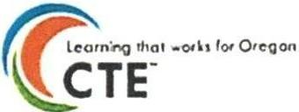
' O REGO N
I
DEPARTMENT OF

. EDUCATIO N
-

I have read and agree to comply with the stipulations addressed in this document.

Name of Member District: Butte Falls Charter School/District


Dr. Phil Long - Superintendent
DocuSign Envelope ID: FFEEA7A7-6CCE-4E8O-85F5 -3AF402FF1BBB

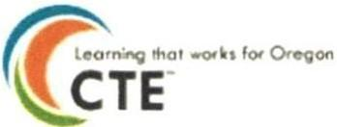
OREGON
lit
DEPARTMENT OF

EDUCATION

I have read and agree to comply with the stipulations addressed in this document.

Name of Member District: Eagle Point School District

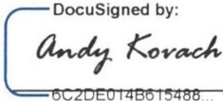

Andy Kovach - Superintendent

r-:Doc uSigned by:
DP

Traci Dulany - SOCTEC Representat ive
Docu Sign Envelope ID: F0A01B4E-CF3B-487F-BEF9-70C0DFF06F84

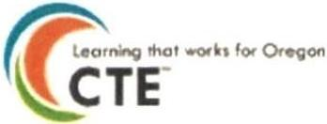
OREGO N
DEPARTMENT DF

EDUCATION
- '

I have read and agree to comply with the stipulations addressed in this document.

Name of Member District: Grants Pass School District

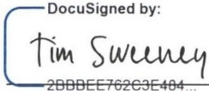

Tim Sweeney - Superintendent

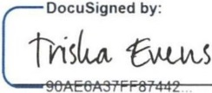

Trish a Evens - SOC TEC Repr esen t at ive
DocuSign Envelope ID: C0873923-C5F A-45BF-81CF-2CBF011C72B4


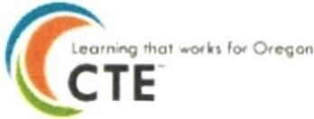
OREGON
DEPARTMENT OF

EDUCATION

I have read and agree to comply with the stipulations addressed in this document.

Name of Member District: Klamath Cit School District

IJ Docu S igne d by:
! oc !

Keith Brown - Superintendent

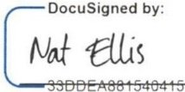

Nat Ellis - SOCTEC Rep resent ative

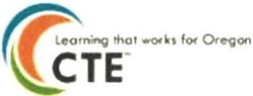
OREGO N
DEPARTMENT DF

EDUCATION
-

I have read and agree to comply with the stipulations addressed in this document.

Name of Member District: Klamath County School District

. Digitally signed by Glen
Glen Szymomak Szymoniak
Date: 2023.05.1 9 1 3: I 0:05 -07'00'

Glen Szymoniak - Superintendent

Tammy Ahalt
Digi tal l y signed by Tammy Ahalt Date : 2023.05.19 08:36:48
-07'00 '

Tammy Ahalt - SOCTEC Representative
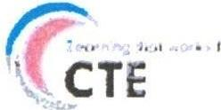
- OREGON
: OEf'j!RTfllENT OF
- · eoUCATIDN

based program of int egrated academic & technical skill content culminating in a technical skills assessment.

I have read and agree to comply with the stipulations addressed in this document.

Name of Member District: Phoenix/Talent School District



Brent Barry- Superintendent

Tam iIn gw ers on Dig i ta yll s i i,r,ned by Tami lngwe rson
Date : 2023 .05.J 1 13:57:1 2 -07'00'

Tami Ingwerson - CTE Represent at ive
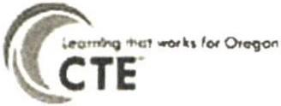
OREGO N
DEPARTIIIOIT 0/F
EDUCATION
- '

I have read and agree to comply with the stipulations addressed in this do cum ent .

Name of Member District: Prospect Charter School/[)istrict

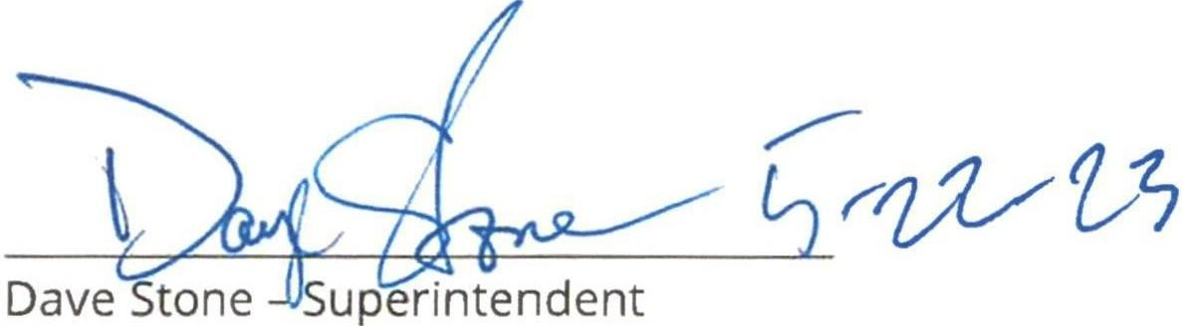

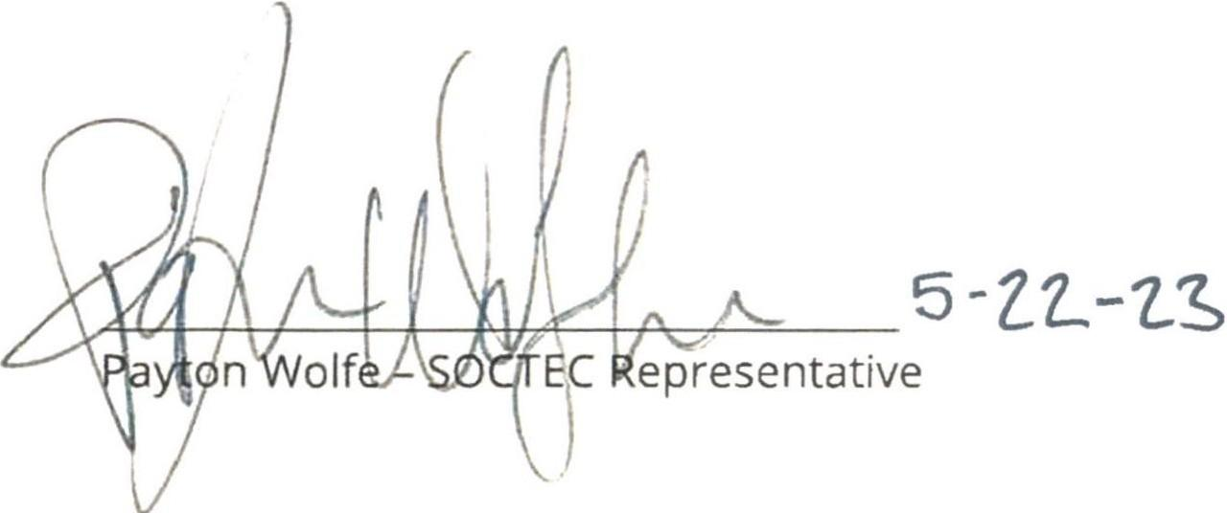

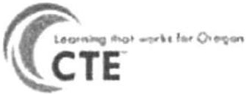
OREGON
DEl'AIITME>n' Df"
•

EDUCATION

I have read and agree to comply with the stipulations addressed in this document.

Name of Member District: Rogue River School District



Patfick Lee - Superintendent

r27_r: J_(}

Brian Pannell - SOCTEC Representative
DocuSign Envelope ID: D9E6A440-2454-49C4-91AC-1F3484 O9A969


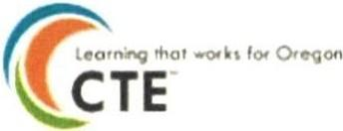
OREGON
DEPA RTMENT OF

EDUCATION

I have read and agree to comply with the stipulations addressed in this document.

Name of Member District: Three Rivers School District



4EA52f I IAE484BE

Dave Valenzuela - Superintendent

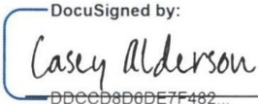

Casey Alderson - SOCTEC Representative


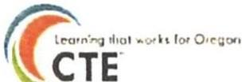
OREGON
I
DEPARTMENT OF
EDUCATION

I have read and agree to comply with the stipulations addressed in this document.

Name of Member Agency: Klamath Community College



Christopher Stickles - SOCTEC Representative
C s

Name of Member Agency: Southern Oregon Education Service District

